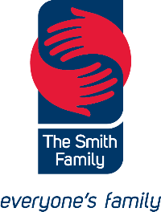

Small Steps, Big Futures

Community insights into preschool participation

Accessible Word Version

Table of contents
Preface 7
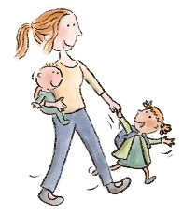
Executive Summary 8
Our model 15
How to read this report 16
Part 1 – Insights into the preschool experience 18
Understanding the benefits of preschool 19
Finding the right preschool 27
Having a simple enrolment experience 35
Feeling welcomed and valued 42
Feeling respected and culturally safe 51
Being offered support 58
Case study: The Hive, Mount Druitt NSW 70
Part 2 – Solutions from the community 72
Ideas from the community 73
Community concepts 80
A local communication campaign, Bendigo, Victoria 81
An Early Childhood Education App, Fairfield, NSW 86
An enrolment helper, Dubbo, NSW 92
A universal screener, Fairfield, NSW 97
Sharing our Knowledge Approach, Wellington, NSW 101
Case study: Nanima Preschool, Wellington, NSW 107
Acknowledgements 110
References 112
Appendix 1 – Project methodology 114
Appendix 2 – Preschool Participation Report 2019 122

Acknowledgement of Country
The Smith Family pays respect to the Traditional Owners and Custodians of Country in the communities in which we work throughout Australia and their connection to their lands, waters and communities. We pay respect to Aboriginal and Torres Strait Islander peoples and cultures, and to Elders, both past and present. We acknowledge Aboriginal and Torres Strait Islander peoples as Australia’s First Peoples and Custodians of the Land. We acknowledge that the land on which our workplaces are located are the lands of the Traditional Owners and Custodians of Country.

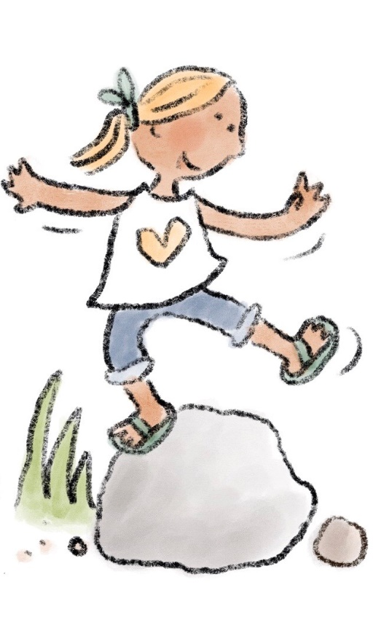
Thank you
Across communities, the project team spoke to many people who generously shared their time and stories, including during a period of great uncertainty and stress due to the COVID-19 pandemic. The Smith Family would like to thank all the parents and family members who helped shape our understanding of how they experience the preschool system. Thanks are also extended to the dedicated early years educators and practitioners who volunteered their time and shared their passion for early childhood education and the children in their community.
This report is dedicated to the children in our communities, all of whom deserve access to high-quality early childhood education.
The Smith Family acknowledges the Australian Government Department of Education, Skills and Employment and the Preschool Attendance Strategies Project Advisory Group for their involvement and support. Thanks are due also to the many staff from across The Smith Family for their contributions to the project.

A Note on Terminology

Due to the wide variation of policy and terminology relating to preschool in the states and territories of Australia, we have included a list of terms with definitions to clarify how they are used in this report.

Attendance
A child who is enrolled and present for booked sessions at an early childhood education service.

Centre based day care (CBDC)
An early childhood education and care service that provides all-day or part-time care for children up to age six who attend on a regular basis. Preschool programs are delivered in these settings, as well as in standalone preschools.

Cultural safety
‘An environment that is spiritually, socially and emotionally safe, as well as physically safe for people; where there is no assault, challenge or denial of their identity, of who they are and what they need. It is about shared respect, shared meaning, shared knowledge, and experience of learning together’ (Williams, 1999).

Disadvantage
A term used to encompass the range of barriers that prevent individuals from participating fully in society, including, but not limited to, low socio-economic status.

Early childhood education (ECE)
A broadly used term that includes education services provided to children up to age eight. The focus of this report is on preschool programs delivered in ECE in the year before full-time schooling.

Educator
A qualified early childhood teacher or educator in a preschool or CBDC setting working directly with children.

Enrolment
The initial intake into ECE and acceptance of a place by the family.

Family
The various carers involved in a child’s primary care, including parents, grandparents, foster carers, legal guardians, adoptive parents, culturally appointed carers and custodial parents.

Parent
This term encompasses biological parents and other carers who have parental responsibility for a child.

Participation
A broadly used term that describes engagement by the child and family with preschool, covering both enrolment and attendance.

Practitioner
This term describes health and community services staff who
work with families, particularly families with young children,
including educators.

Preschool
As the language to describe ECE programs under the Early Years Learning Framework in the year before school differ across jurisdictions, for ease of reading, this document uses the term ‘preschool’ to describe both preschools and kindergartens.

Preface
Research shows that all children benefit from preschool, and we know that children experiencing disadvantage and vulnerability stand to benefit the most. The benefits of preschool are lifelong. When children start primary school ‘ready to learn’, they have the best chance of thriving. However, when children start school without these foundational skills, they are more likely to experience a difficult transition and struggle throughout their education and beyond.
We know that many families find it hard to send their children to preschool. The National Partnership on Universal Access to Early Childhood Education (ECE), also known as the Universal Access National Partnership (UANP), has been effective in making preschool more accessible to Australian families and has built up the sector’s capacity to deliver quality preschool services; however, some children and families are being left behind. Publicly available data indicate that up to one in 10 children still miss out.
Most families will overcome the barriers we have identified through the project, such as complex enrolment systems and finding quality care, but many will not. Problems such as poverty, low literacy, family violence, intergenerational trauma, ill-health or disability and a lack of trust in government and institutions are compounding challenges that can seem insurmountable. In addition, the perceived cost of preschool and childcare—despite available subsidies—can deter some families from even exploring the possibility of preschool.
The Smith Family undertook this research project to add to the evidence base on what works to raise preschool participation for children experiencing disadvantage, with a particular focus on the lived experience of families and practitioners.
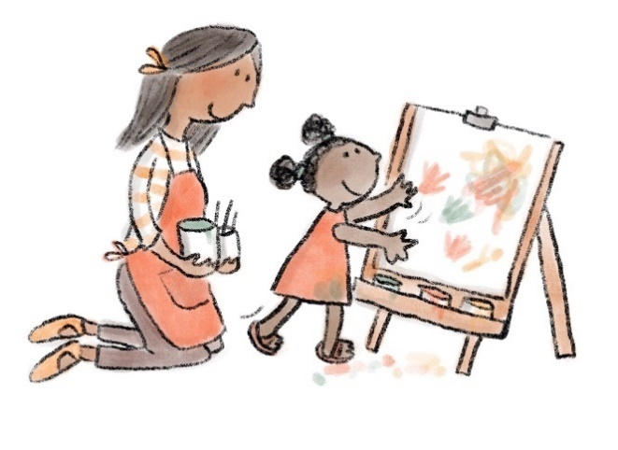
Originally intended to be a longer multi-year project that included the trialling of solutions and implementation of initiatives, this project was funded for the completion of Phase One which was broken down into two stages conducted between July 2019 and April 2021. Building on a literature review and scan of programs implemented by governments, we undertook consultations and qualitative research in the first stage to understand the barriers to participation in preschool. We then moved to a human-centred design (HCD) approach more suited to working with complex problems. Our participatory approach invited families and practitioners to bring their experiences and insights into developing solutions.
We took this approach because the evidence shows that solutions to complex problems are more likely to succeed when developed with the people who are impacted. We anticipate that different communities will prioritise different solutions, so we do not consider that this work is ‘finished’.
Throughout the report we have shared comments from the community that reflect the themes we encountered, or have implications for solution design.
With a few small steps, even more children will benefit from preschool in preparation for their own big futures.

Executive Summary

The purpose of this report is to document the outcomes of our participatory process with different communities, noting how families’ experience of the system is influenced by ‘place’, and as well as to explore possible solutions. This report builds on The Smith Family’s Project Interim Report and Preschool Participation Report 2019, which offer substantial detail on the policy context and service landscape that is not reproduced here.
We spoke directly to families with recent experience of the ECE system, as well as with early childhood educators and early years service practitioners. They described the barriers present throughout the preschool journey, which are felt most by people living in circumstances of disadvantage or vulnerability. Some of these barriers are personal and local. Many are systemic. However there are opportunities to improve families’ experience by providing support or adjusting policy settings.

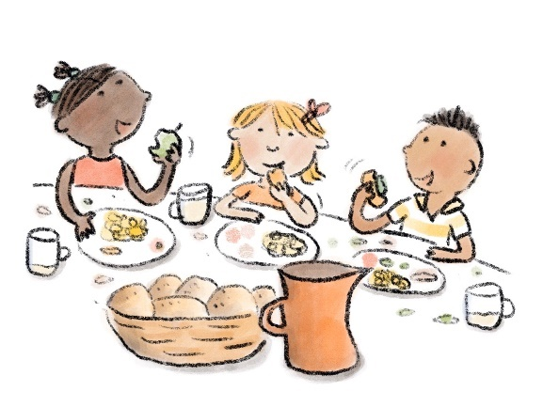
This work was conducted in four communities in New South Wales and Victoria:
- A regional community working to overcome the impacts of intergenerational poverty.
- A metropolitan location with high rates of disability, a high proportion of families from
diverse cultural backgrounds and many new arrivals to Australia.
- A small outer regional town with a high percentage of Aboriginal and Torres Strait Islander peoples.
- A large regional centre.
We engaged with these communities and asked them what they thought would help improve preschool enrolment and attendance in each of these locations. Each had its own strengths and challenges and varying levels of capacity to meet the goal of enabling every family to send their child to preschool. In each location, we encountered families and practitioners with strong views on how to better meet the needs of families in their communities. Although each community had a unique perspective, there was also remarkable agreement across communities on what changes are needed.
We heard that relationships are everything. In all our interactions, the importance of connection, trust and the value of local relationships was emphasised. For families with low trust in government and government systems, building trust is critical to successful engagement with the preschool system. Relying on preschool services to initiate and nurture these relationships in the current environment is not always realistic, given the range of pressures on these services.
We distilled the views collected in our discussions to obtain insights into what is and what is not working across the preschool engagement journey from the perspective of families. We then invited participants to prioritise their needs and work with us to develop and test a concept that would meet that need.
The logical next step is to trial these concepts in place, to identify quickly whether they will succeed or fail. Next steps have been articulated for each of the concepts described in the report.

Findings

Through our research, we identified a range of specific barriers families face which can prevent their child’s enrolment and regular attendance at preschool. There are also a number of broader, systemic issues that need to be considered when designing interventions:

The system is complex, and for families experiencing vulnerability this complexity inhibits engagement with early learning.
We found that families have difficulties navigating the ECE system. The interactions of the Commonwealth, State and Territory systems, and the range of different ECE options available makes it hard for them to know where to start. Added to this, enrolment and subsidy application processes assume a level of agency, literacy and mobility that is beyond some families to navigate.
Families often do not understand their out-of-pocket expenses for ECE, which impacts their ability to make an informed choice. Further, the interaction between the hours available under the Child Care Subsidy preschool exemption and centre based day care (CBDC) session times result in not all children having access to 600 hours of preschool in the year before school.

We need to better understand who is missing out on preschool, and what works to support participation.
There is currently no nationally agreed data set on preschool participation, so it is not possible to identify precisely who is missing out. This limits efforts by governments, philanthropic organisations and ECE providers to target approaches to greatest need.
Billions of dollars are invested in ECE nationally, yet no evaluation system is in place to guide this investment. A nationally agreed evaluation framework would support systemic responses to ECE investment and allow for more targeted needs-based funding.

Educators need more resources to support them to engage with vulnerable families.
Educators told us that they know how important relationships are, but they struggle to find the time and, in some cases, the right training to build positive relationships with vulnerable families and to respond to the needs of the child.
This has particular significance for Aboriginal and Torres Strait Islander children, who continue to attend preschool at lower rates than other demographic groups, despite the data indicating high enrolment rates. Our research found that if culture is embedded into the practice of the preschool, engagement is stronger, leading to increased participation. The challenge is to enable more practitioners to consider cultural safety through authentic engagement with local Aboriginal and Torres Strait Islander communities.

From this broader context of systemic issues, we recommend that any intervention needs to be designed with the human experience in mind by:
- Adopting a family-focused approach, with greater responsiveness to families’ needs.
- Enhancing connections between government sectors, such as health and education, and encouraging collaboration across the early education and family service system to create a more seamless experience for families.
- Involving the local community in developing solutions.

Major steps forward

National priority
In 2008, the Council of Australian Governments (COAG) made the attendance of all children at a quality preschool program for 15 hours a week or 600 hours annually in the year before full-time school a national priority.
(ABS, 2013)
The Australian Government has committed $453.2 million for preschool in 2021 under the National Partnership on Universal Access to Early Childhood Education (UANP), bringing the total amount of funding available since 2014 to over $3.2 billion.
(Department of Education, Skills and Employment, 2021)

Enrolment has increased, but attendance needs to continue to improve.
Under UANP arrangements preschool enrolment rates have increased significantly, from around 12% before the UANP started
(in 2008) to around 95% nationally.
Aboriginal and Torres St Islander enrolment rates have also increased significantly, now sitting at 96% nationally.
(Department of Education, Skills and Employment, 2021)

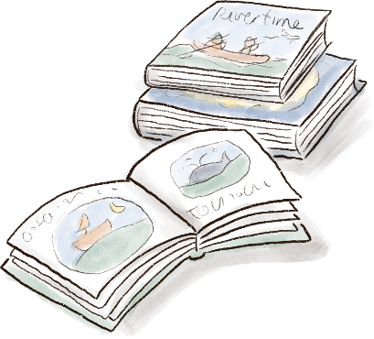
Work still to be done
At present, more than one in five Australian children are considered developmentally vulnerable at the time they start school.
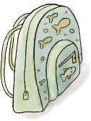
Publicly available data indicates that up to one in 10 children still miss out on preschool.

Who is missing out?
- Aboriginal and Torres Strait Islander children.
- Children living with disadvantage and in circumstances of vulnerability.
- Children living in outer regional, remote and very remote areas.
These groups are over-represented in the cohort of children who do not fully participate in preschool at the level identified by COAG.

The preschool family experience
The journey that families experience when engaging with a preschool program is often not linear. There is complexity at each stage as well as opportunities to engage with and build trust with families.
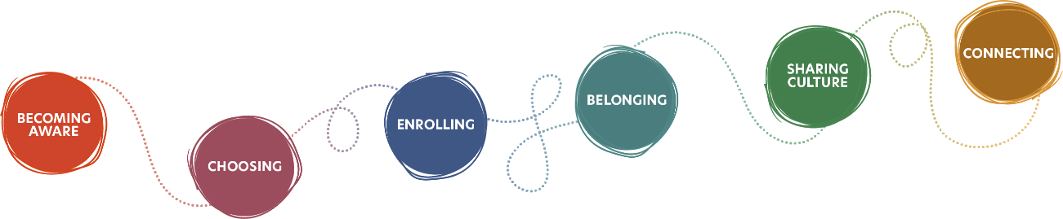

Becoming aware: The first stage of that journey is understanding the benefits of preschool
- Preschool is valued by parents, but many are unaware of the long-term benefits of early learning for their child and the community.
- In the absence of a clear message about the value of preschool, parents receive their information through informal networks.
- Some parents, particularly those from diverse cultural backgrounds or those not in the formal workforce, believe that preschool is not
for everyone.
- Building trust with vulnerable families is crucial to helping them participate in preschool.

Choosing: Next is finding the right preschool
- Cost is a significant barrier for families and plays out differently in different contexts.
- Local services are highly value d by parents, with location and transport playing a significant role in access and attendance.
- Families need clear information on services to make an informed choice, however, such information is surprisingly difficult to access.
- Parents of children with a disability or complex needs find it difficult to secure their preferred preschool, and services are struggling to respond to the rising numbers of children with complex needs.

Enrolling: Having a simple enrolment experience would help all families, and especially those experiencing disadvantage
- A simpler and more responsive enrolment process can help parents engage with preschool.
- Navigating MyGov and applying for the Child Care Subsidy can be difficult for parents, and support options are limited.
- The progressive pre-filling of forms and standardising data requirements would reduce the burden on parents and practitioners.
- Some families need one-on-one help to complete the enrolment process.

Belonging: Once enrolled at preschool, families need to feel welcomed and valued
- Families place high value on the quality of the interactions they have with practitioners.
- Educators can build trust with culturally and linguistically diverse (CALD) families by understanding and including their culture and language.
- Food insecurity is a problem for many families living with disadvantage, and providing packed lunches is more generally a source of anxiety.
- Preschools can be a key touchpoint in identifying disabilities and developmental delays early and providing support.

Sharing culture: Aboriginal and Torres Strait Islander people told us that feeling respected and culturally safe is essential
- Cultural leadership of preschools enables a strong ECE model that responds to Aboriginal and Torres Strait Islanders children’s needs.
- Enabling cultural safety includes fostering a living culture that is connected to identity, place and people.
- Community connections embed the preschool in wider Aboriginal and Torres Strait Islander cultures and build trust.
- There are challenges transitioning from a culturally safe preschool to a mainstream school.
- Participatory decision-making with Aboriginal and Torres Strait Islander people would help integrate cultural safety within ECE services
and policies.

Connecting: And finally, educators are in a good position to offer support to children with additional needs
- Educators require time and training to build relationships with vulnerable families.
- Educators can play a critical role in connecting vulnerable families with other support services.
- Families benefit when early childhood educators collaborate with local health, community services and schools.
- As the number of children with complex needs rises, educators struggle to meet the needs of all children.

Our model
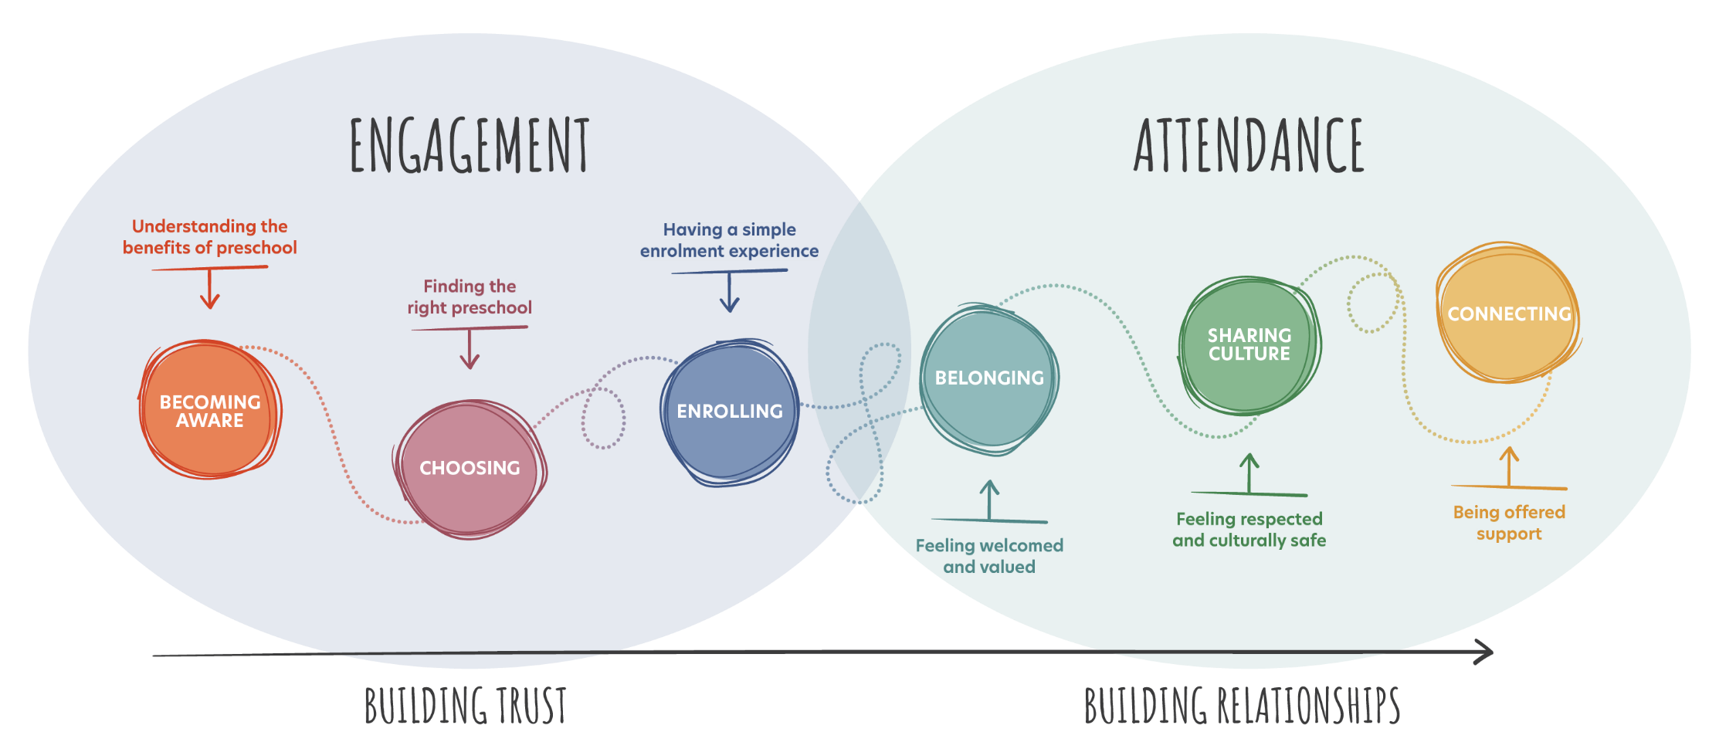
This journey offers a useful model for us to design experiences that meet the needs of families at each stage as they move from initial engagement into attendance. Each stage offers opportunities to build trust and build relationships to enable ongoing participation in a preschool program.
All stages of this experience can affect how readily families engage with and value preschool for their child. Our report is structured to follow the family journey and highlight the kinds of experiences that must happen at each stage for families to overcome barriers and fully engage with
a service.

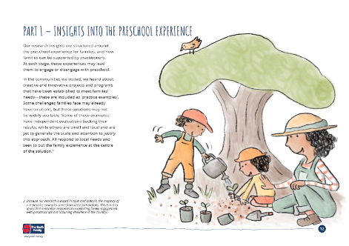
How to read this report
There are many voices in this report. We have structured it to first present our research and insights, and then showcase the ideas that we developed with local communities.

Part 1 – Insights
Here is where we synthesise what we heard from families and practitioners about their experience of preschool. We share quotes and stories that highlight common experiences.
Practice examples: Throughout Part 1, we have highlighted innovative examples of solutions that have had success in increasing participation. Many of these examples are from Victoria and New South Wales, reflecting the locations we focused on in the project.

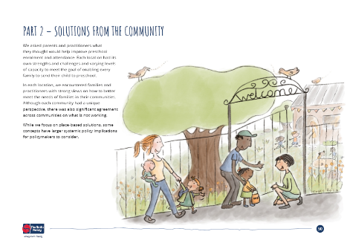
Part 2 – Solutions
In this section we show the wide range of ideas we heard from the four communities.
Ideas from the community: these are the many ideas that emerged from our workshops.
Community concepts: these are the ideas that the workshop participants prioritised to take forward and develop into a concept for testing. It is worth noting that other ideas may be prioritised by other communities.

The preschool family experience
You will see these journey icons throughout the report, and the colours and icons will help you navigate the report.
The framework is also used to highlight how each practical intervention—practice examples, ideas and concepts—relates to one or more stages of the journey.

Appendices
We have included two appendices:
1. Project methodology, where we describe our approach and research process.
2. Our Preschool Participation Report, which provides more detailed data.

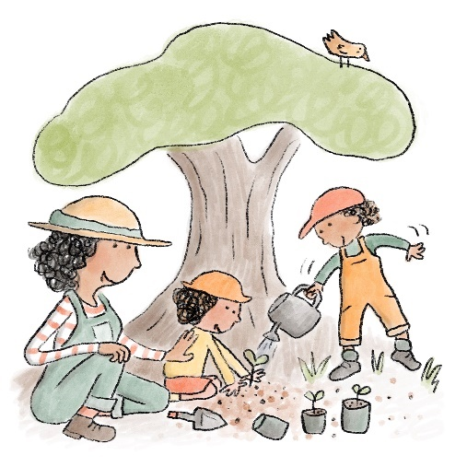
Part 1 – Insights into the preschool experience
Our research insights are structured around the preschool experience for families, and how families can be supported by practitioners. At each stage, these experiences may lead them to engage or disengage with preschool.
In the communities we visited, we heard about creative and innovative projects and programs that have been established to meet families’ needs—these are included as ‘practice examples’. Some challenges families face may already have solutions, but those solutions may not be widely available. Some of these examples have independent evaluations backing their results, while others are small and local and are yet to generate the scale and attention to justify this approach. All respond to local needs and seek to put the family experience at the centre of the solution.

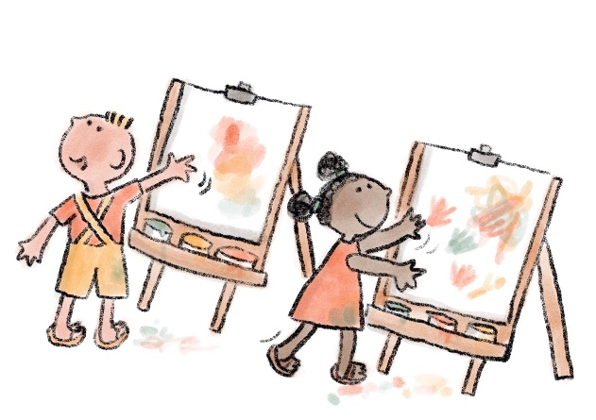
Understanding the benefits of preschool
While many families may value early learning services, they may not be aware of how important attending a preschool program is to their child’s development. We also heard that many families fear judgement of their parenting and have a general lack of trust in government services which inhibits them from engaging with preschool. Learning about the value of preschool is the first step in building trust with families. The insights below highlight the importance of explaining the long-term developmental benefits of preschool to parents more effectively.

What we heard

Preschool is valued by parents, but many are unaware of
the long-term benefits of early learning for their child and
the community
Many parents value preschool and can see the immediate benefits when their child participates in a quality program. This also frees up time for employment, caring for the elderly and for daily activities.
“They feed the kids which saves money. They sleep better because they run around more. And I’m happier because I get rest and
a break.”
—Parent, Bendigo, VIC
“[My kids have] a better day being at preschool than being at home I don’t have the time to play with the toys and do the cleaning and the cooking.”
—Parent, Wellington, NSW

However, there remains a perception of early learning services as ‘babysitting’. The fact that preschool is not compulsory appears to lead many families to feel that it is unimportant to preparing their children for primary school and beyond.
“They are aware of the services, but not aware of the wider benefits for kids, families
and communities.”
—Practitioner, Bendigo, VIC
“Some parents aren’t aware of educators’ qualifications and view them merely as ‘glorified babysitters’.”
—Practitioner, Wyndham, VIC
“We do a lot of education to raise awareness among parents away from childcare to early childhood education. We see a lot of parents who come and say, ‘Oh I didn’t know you did that’.”
—Practitioner, Bendigo, VIC
There is a need for a clear narrative that is based on developmental neuroscience, as well as explaining the broader collective benefits to parents and communities.
“Kinder should be thought of as important as a doctor service.”
—Parent, Bendigo, VIC
“Centrelink and schools need to tell parents about preschool.”
—Parent, Fairfield, NSW
There is growing evidence about the long-term impact of quality early learning on children’s educational attainment throughout their lives.
(Thorpe, 2020) It is important that these benefits are communicated to parents in a way that helps them understand, value and prioritise preschool.

Practice Example: Thrive by Five campaign, National

Purpose
Thrive by Five is an initiative of the Minderoo Foundation that is campaigning to transform our current childcare system into a comprehensive, high-quality, universally accessible and affordable early learning system. The Thrive by Five campaign advocates for effective policy and investment in early learning and development across Australia. The campaign is focused on partnerships with research institutions, investments at a community level, and engagement with policy makers to help build the case for change.
Thrive by Five aims to demonstrate the importance of high-quality early learning to children’s development and to provide the opportunity for parents to work if they choose to.
The campaign uses key messages, such as that 90% of the size of a child’s brain develops by the age of five and that 22% of Australian children are developmentally vulnerable when they start school.

Possible impact
Thrive by Five aims to make early learning and childcare universally accessible and high quality. This approach aims to reduce the number of Australian children who start school developmentally vulnerable and also supports the optimal development of all children. Affordable, high-quality childcare and preschool would also increase workforce participation for women and could help address the lifelong economic disadvantage many women face.

Limitations
The goal of the Thrive by Five is to build a national, networked strategy without losing coherence. The early learning sector is complex and
has many stakeholders. Arguments to motivate different groups across the political divide are needed to make this a bi-partisan issue of
collective benefit.

More information
https://thrivebyfive.org.au/

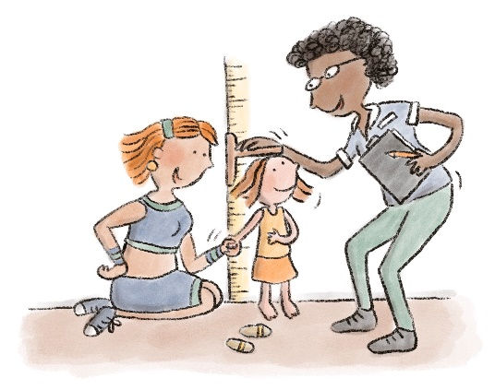
In the absence of a clear message about the value of preschool, parents obtain their information through informal networks
The messaging about the purpose and nature of ECE is fragmented and inconsistent, which leaves families unsure about whether they should send their children to preschool. Early learning services, particularly standalone preschools, do not always succeed in communicating the value of their work.
“Long day cares tend to do their own advertising, but standalone kinders rarely do. And there is no centralised campaign for a region or State.”
—Practitioner, Bendigo, VIC
The lack of a cohesive campaign means that the main form of influential messaging comes through (sometimes poorly informed) word of mouth.
“Given the lack of information or misinformation provided by local services, word of mouth is far more reliable for parents in the community.”
—Practitioner, VIC
“Word of mouth is the key—other parents who have had a good experience do the marketing.”
—Practitioner, Wellington, NSW
“My friends tell me that if you send your child to preschool they will be bored when they get to kindy—it is too many years
of school.”
—Parent, Fairfield, NSW
As well as spreading potentially incorrect information, there is a risk that families that are disconnected or lack social networks may miss out on the message entirely.
“Some parents have a pre-conceived idea of what they expect kindergarten to be. It would be good to have help in de-mystifying what kindergarten is about. There are so many myths around what it is like.”
—Practitioner, WA

Some parents, particularly those from diverse cultural backgrounds or those not in the formal workforce, believe that preschool is not for everyone
Beliefs about the place of children within the family may dissuade parents from enrolling their child. Families from culturally and linguistically diverse backgrounds may believe that children should be at home with family in the early years.
“Many parents don’t feel that they should put their kids in care. They think ‘If I’m not working, should I be using childcare?’”
—Practitioner, Bendigo, VIC
“Aboriginal and Torres Strait Islander communities rely first and foremost on family and community members.”
—Practitioner, WA
We heard that some parents do not believe that school is a good option for their child, particularly if they themselves had a negative experience
at school.
Many families think about ECE as primarily about childcare to enable workforce participation. The Child Care Subsidy activity test sends the message that ECE is for working parents, leading some parents to think that they should not enrol their child if they are not working.
Parents with children with a disability may believe that their child is unable to attend preschool.
“[In Victoria] Kindergartens would often keep a few spots because often families with a disability will realise very late that their child can attend and will apply.”
—Practitioner, Bendigo, VIC
These families are likely to use early intervention support services rather than see a maternal and child health (MCH) nurse. Often, they are not aware of the support available to enable their child to attend preschool.
“Families with a child with a disability are probably not going to those main touchpoints—not the MCH nurse or the local GP.
They don’t want to hear about their child failing to reach each milestone. They will be going to early intervention specialists,
or not at all.”
—Practitioner, Bendigo, VIC
Parents should know that preschool is for all children.
“Many cultures place importance on the grandparents providing care in the early years, and the importance of preschool is not recognised.”
—Parent, Fairfield, NSW

Building trust with vulnerable families is crucial to helping them participate in preschool
We heard that many families are reluctant to engage with ECE out of fear of allowing government services into their lives. They can be highly sensitive to judgement about their parenting and lifestyle, and many fear government intervention.
“Kinder is the bottom of that survival heap.”
—Practitioner, Bendigo, VIC
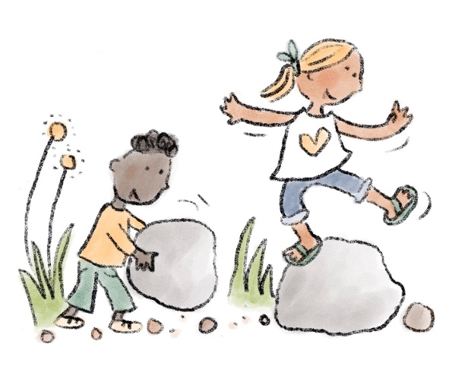
“Some [practitioners] are judgmental about parent arrangements. You can’t trust everyone.”
—Parent, Bendigo, VIC
Engaging with preschool services is a difficult choice for some parents between ensuring their child participates and having to fit into the system.
“There is a lot of shame. Some people don’t want Additional Child Care Subsidy funding because they have to admit their children are at risk of harm. They feel like it goes on their ‘file’.”
—Practitioner, Bendigo, VIC
Relationships built on trust and respect between families and practitioners can help overcome these barriers. The stronger the relationship with the preschool and staff, the more likely families are to enrol and stay engaged.
“For vulnerable families, coming into an organised setting, there is going to be a sense of judgement—that their parenting might be judged, or their choices might be judged.
For young parents, there is that sense of judgement already.”
—Practitioner, Bendigo, VIC

Practice Example: Working Together, Tasmania

Purpose
Working Together (WT) is a co-designed and evidence-based Tasmanian Government initiative. It provides the families of eligible three-year-olds with free early learning and support to address participation barriers. Across 2019–20, WT worked with 21 ECE and Care centres to provide 176 children with early learning services.
An independent evaluation by the Tasmanian Council of Social Service found that families felt their children had gained skills that significantly contributed to the successful transition to kindergarten.
‘James is going really well. He has just excelled at everything. Social skills, becoming independent—he is always off doing his own thing. It’s hard to describe it all because it’s such a big change. I think it’s the educators that have made that happen. They give James that can-do attitude. Instead of “I can’t” it’s “I can”’
—Working Together Parent, TAS

Possible impact
- Enhanced skills and relationships for children and families to ensure a successful transition to kindergarten.
- Improved connectivity between referral service partners, early education service providers, schools and the wider service system.
- Positive impact in service domains of participation and community engagement. Improvements in capacity, capability and practice.

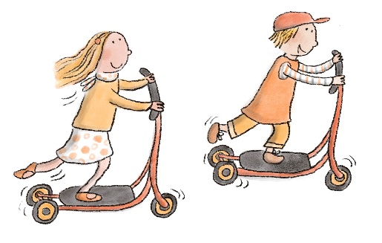
Limitations
- The co-design process takes time, and consideration for this must be factored in when planning for design and implementation.
- The program incrementally increases available places in line with sector capacity to ensure expected service quality.

More information
https://www.education.tas.gov.au/wt

Finding the right preschool
There are many factors that families must consider when deciding to send their child to preschool. How much will it cost? Is there space for my child? How will I get there? We found that some of these things, including location, availability, quality and flexibility, can be insurmountable barriers for families experiencing disadvantage. We heard that this process could be improved by providing clear and relevant information, particularly about cost, and ensuring that local services are available so that each child can access quality preschool.

What we heard

Cost is a significant barrier for families and plays out differently in different contexts
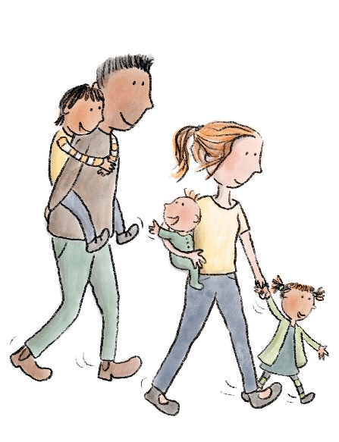
Despite the subsidies in place to help parents send their children to preschool, cost remains a significant barrier to participation for many families, particularly for those experiencing disadvantage. And unfortunately, there are families who do not understand that Child Care Subsidy is available for all preschoolers, regardless of their parents’ working status.
“Money is the biggest barrier, and it is worse if you can’t access Centrelink or Medicare benefits, which is the case for some asylum seekers and newer arrivals.”
—Practitioner, Fairfield, NSW
“It is common for members of this community not to send their children to kinder, in order to save money for primary school.”
—Parent, Wyndham, VIC
“When people talk about ‘funded kinder’, families think ‘free’ and they feel they are being tricked, and they don’t see the value. And people are reluctant to mention this.”
—Practitioner, Brimbank, VIC
We heard from practitioners that when governments made childcare fee-free for all families as part of the COVID-19 response, there was an increase in applications and interest from areas with high levels of disadvantage. Anecdotal evidence indicates that there was also an increase in first time family engagement with preschool services.

During our consultations, we found that many families were ambivalent about talking about cost and, at times, underplayed its impact. These families are sensitive to even small adjustments in cost. For instance, we heard that when the subsidy increased to 85%, [when the child care rebate was replaced by the child care subsidy], some families experiencing disadvantage in Bendigo were able to send their child to an additional day of care.
“Without a stable income it’s difficult to reach the right services for your child.”
—Parent, Dubbo, NSW
Parents must have clear information on costs and eligibility, as we heard that a lack of clarity can deter families from applying to preschool. To understand the exact costs, families must apply first. The application process can be lengthy and difficult, and families are often unsuccessful due to inflexible policies.
“If it was cheaper, I would have had my kids in earlier and more days.”
—Parent, Bendigo, VIC
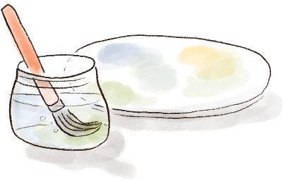
“The subsidy information may be misleading depending on the system that the child pursues. So, the [full fee] would cause parents to say that there is no way that they can afford it. The difference between the maximum benefit and the actual cost also needs to be explained—it may not be free.”
—Practitioner, Fairfield, NSW
“I would like to enrol in a certain school or a certain area, but I would like to know what it is going to cost. Each school might cost different. It is definitely going to help to know,”
—Parent, Fairfield, NSW

Practice Example: Goodstart Increasing Access and Participation program, Victoria

Purpose
National early learning provider Goodstart created the Increasing Access and Participation (IAP) program in March 2019 to respond more effectively to referrals from the Victorian Department of Health and Human Services child protection workers and family caseworkers from other services in the state. Rather than caseworkers referring to centres directly, the IAP program provides an Engagement Officer to work closely with families to support them in engaging with preschool services.
The Engagement Officer brings together a ‘team around the child’ to ensure that every family has the best possible chance of success. Along with the caseworker and the relevant centre director and staff, the Engagement Officer invites other services working with the family to participate in meetings, such as allied health. The Engagement Officer helps families navigate the enrolment process to ensure they access the funding support they are entitled to and have no fee costs if eligible. Families who are not supported through the Centrelink process can inadvertently end up in debt, and the fear of how much services will cost is often enough to put parents off even thinking about preschool for their child. The Engagement Officer has detailed knowledge of Centrelink and the application process and can support families every step of the way.

Possible impact
This program targets some of the most vulnerable children in Victoria. Children with child protection involvement are more likely to start school behind their peers and have difficulty catching up (Laurens, 2020). The program acknowledges that some families need individual, dedicated support to overcome barriers to participation in ECE.
“We would have lost a lot of families if we didn’t support them through the process.”
—Practitioner, VIC
By taking a team approach, the program can address all the issues that may prevent a child from attending preschool. This also has the benefit of building the capacity of centre staff to support families experiencing vulnerability.
The program continues to follow up with families at eight-week intervals to ensure they continue to be able to participate.
Since the program launched in March 2019, 247 children have been supported.

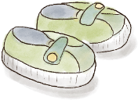
Limitations
The program was made possible by combining funding from the Federal Government’s Community Child Care Fund, the Victorian Government’s Early Start funding and Goodstart’s own Social Inclusion funding. Few smaller services would have the resources to develop a comparable program or dedicate the staff time to support the complex needs of families. As a national not-for-profit, purpose-driven organisation, Goodstart has the capacity to put this program together.

More information
https://www.goodstart.org.au/about-us/inclusion/programs-we-run

Local services are highly valued by parents, with location and transport playing a significant role in access
and attendance
The location of preschool is a significant issue for many families, particularly for those without a car or transport and those juggling more than one child for drop off and pick up. Proximity to home, school or work is highly important to parents; however, unlike schools, preschools are not required to take children from their local area.
“A lot of parents walk to and from school. In the middle of summer, a lot of parents keep their kids at home as it is too difficult to get there. Or in wet weather”
—Parent, Dubbo, NSW
When access to transport is a challenge, preschool is generally prioritised behind work and school; therefore, children are more likely to miss a preschool session. This also interacts with parents’ sense of value for money.
When services are local, families experiencing vulnerability are more likely to participate. We also heard that when practitioners notice that families have stopped attending, there is value in them reaching out directly or indirectly to offer support.
“Our Director will walk to family homes and walk with the kids to make sure they are going. These community connections
are important.”
—Practitioner, Bendigo, VIC

Families need clear information on services to make an informed choice, however such information is surprisingly difficult to obtain
When there are several preschool programs in the local community and parents have a choice about where to send their child, they can be overwhelmed when trying to understand which service is best for their family. The complexity of assessing the type of care on offer, the service hours availability and the waiting lists mean that deciding can be difficult for parents.
“Families might identify what they want but where to go, how to go, or the processes to get there are so complicated that they might get to the first step and then stop at that point.” (Practitioner, Dubbo, NSW)
“We have a bus. We wouldn’t get half the kids we do without a bus.”
—Practitioner, Dubbo, NSW
Preschool programs can be delivered in different contexts—from standalone preschools to those embedded in CBDC settings—all offering different levels of real and perceived quality and flexibility for families. Due to the need to provide 15 hours of preschool for each child, services may deliver these hours in many different ways, and the challenge for providers is that the preschool activity test exemption for Child Care Subsidy settings does not always align with their sessions. Some centres may offer short sessions over a number of days, while others try to offer longer hours over fewer days. We also heard that the session times offered do not always work for families juggling other responsibilities, such as work or other children.
The complexity of the system and the lack of flexibility with hours and days of attendance and availability is a problem in relation to family choice. This is particularly challenging for families coping with high levels of vulnerability, who may find it difficult to plan ahead.
Preschool services and policy makers could work to address the mismatch between the preschool activity test exemption and the session times offered. Some CBDC centres have addressed this by offering before and after care that wraps around preschool sessions, but standalone preschools would struggle to offer this.
“Parents often make the choice based on availability—parents are motivated by particular days, needs around work. Often a very practical choice.”
—Practitioner, Bendigo, VIC
“Why can’t kinder be run all day so that parents can just check in or check out whenever it suits them? Or collaborate with families at the beginning of the year to get a collective agreement on start times?”
—Practitioner, Brimbank, VIC

Practice Example: Uniting Links to Early Learning, NSW

Purpose
An innovative, evidence-based and scalable home-visiting program that is highly successful at working in partnership with families, other services and ECE providers to support vulnerable children in gaining access to more opportunities to learn.

Possible impact
Links to Early Learning works by providing an experienced early childhood professional who engages one-on-one with parents and carers. This professional assists families in successfully navigating the community services sector to break down any barriers to accessing and maintaining access to quality early learning programs and set their child up for a successful start to school. The program team also plays an important role in building the capacity of centre staff to understand and meet the needs of children and families experiencing vulnerability and disadvantage.
The program is located in south-western Sydney, where preschool enrolment is below the state and national average, and the number of children assessed as developmentally vulnerable in two or more domains is much higher than the state and national average. The program targets families from diverse backgrounds (including refugee and asylum seekers), Aboriginal and Torres Strait Islander families, children and parents with disabilities, young parents and those from low socio-economic backgrounds. It directly addresses the need for relationship-focused support for families that are less likely to access early learning. The program has been evaluated and is showing promising results.

Limitations
The program is struggling to meet demand as it is providing a much needed service. Short term funding to the program creates risk that service continuity will be disrupted and community engagement will be compromised.

More information
https://www.uniting.org/services/family-services/facility/uniting-links-to-early-learning

Parents of children with a disability or complex needs find it difficult to secure their preferred preschool,
and services are struggling to respond to the rising numbers of children with complex needs
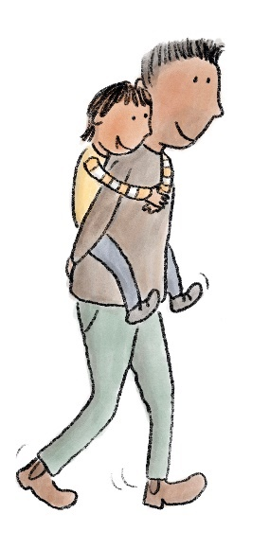
Families looking for support for children with disabilities and complex needs struggle to find the right preschool in their local area. Parents expressed the wish that their child could be accommodated in their local preschool rather than having to travel to another area. Finding community support offers additional challenges to these families, and if there is more than one child in the family, the challenges multiply.
We heard from educators that the number of children with complex needs seeking preschool placement is rising dramatically, and preschools are struggling to meet the needs of all children. Some organisations observed that reduced administrative impost during the COVID-19 response fee holiday made it possible for them to accept children with complex or
additional needs.
There was also a lack of understanding of the support and funding available for children with disabilities, resulting in less uptake of these services when they were most needed.
“There is a pretty poor uptake of the Inclusion Support Program in the area. It is quite onerous to access ISP and it can’t work with centres until the child is enrolled—therefore centres will be hesitant to take the child if they don’t know whether they are going to get the support.”
—Practitioner, Fairfield, NSW
“Centrelink is the most challenging interaction. There are lots of payments that parents may be entitled to, but staff at Centrelink don’t actively offer them. You have to know about them or hunt them down. My child has Asperger’s and we weren’t told of the things that you can access. It was just by chance that [a peer] mentioned it. Everything I have learned about Centrelink I got through word of mouth.”
—Parent, Windermere, TAS
There is an opportunity to make these support programs easier to apply for and administer.
“Parents want to go to their local preschools. We need to make those local preschools supportive of kids with diverse needs.”
—Parent, Fairfield, NSW

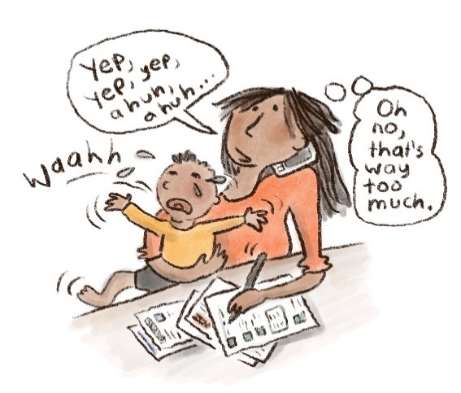
Having a simple enrolment experience
Having chosen a preschool, we heard that the process of enrolling can be a significant barrier for many families and may deter them from continuing with the process. Families described being frustrated and overwhelmed by the complex and repetitive paperwork required. There was confusion about important dates for enrolment and concerns about missing out on a place for their child. Gathering official documents, such as birth certificates, can also be challenging. For many families, difficulties in enrolling may be the final straw that prevents them from engaging and may also hinder the development of a trusted relationship with the preschool.

What we heard

Simpler and more responsive enrolment processes can help parents engage with preschool
Families from a diversity of backgrounds described feeling overwhelmed by paperwork. Digital literacy can be a significant barrier for families experiencing disadvantage.
“When enrolment forms went online, it was difficult because I only use my phone.”
—Parent, Bendigo, VIC
Enrolment is particularly difficult for families from diverse cultural backgrounds. Information is often not available in their preferred language, and parents struggle to complete complex forms. A lack of proficiency in English impedes families from obtaining the information they need on what preschool options are available and why preschool is important. Astonishingly, childcare services are ineligible for the free services offered by the national Translating and Interpreting Service, reducing the options for families to obtain information. (TIS, 2021)[Q3]
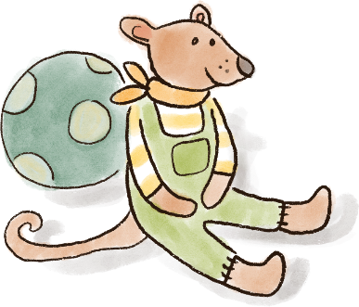
“When I can’t speak English, I can’t fill in the forms. Here in Australia, everyone is busy. You can’t ask your friends to translate for you all the time.”
—Parent, Fairfield, NSW
A review of the enrolment process, with a view to simplify and support enrolment would be beneficial to families. We note that in Victoria, additional funding has been allocated to local councils to create a central enrolment point for all centres in the Local Government Area, in time to support the rollout of free 3 year old kinder in Victoria.
“It’s the knowledge barrier and the language barrier for those families.”
—Practitioner, Bendigo, VIC

Practice Example: Loddon Mallee Preschool Association Kindergarten Central Enrolment Service, Victoria

Purpose
To provide a central enrolment point for families looking for a preschool program for their child. The LMPA service provides a single application form for families to express interest in several (but not all) standalone preschool programs in the Bendigo area. Centres can choose to participate in the central enrolment service, and doing so is not compulsory.

Possible impact
The LMPA service aims to reduce the administrative load on parents by offering a single place to express interest and enrol in multiple preschool services, rather than having to apply to each centre. The LMPA service grew out of a parent cooperative that identified the need for a simpler way for families to choose and enrol in a preschool program. The service describes one of its aims as helping to collect enrolment data to support the management of capacity and utilisation.

Limitations
The LMPA service is limited to the preschool programs that choose to participate, which are mainly standalone preschool services. Preschool programs delivered within a CBDC setting often have their own enrolment processes.
Another limitation is that when parents are offered a place at a service, they are required to complete a new set of service-specific forms that are often paper-based and are not pre-filled with the information they have already provided. LMPA conducted a trial in which pre-filled forms were given to parents, but this has subsequently been halted due to feedback that family information changed frequently, and LMPA lacked funding to provide this additional workload. A future solution could be a new platform or a standardised software service to update information where necessary.

More information
https://www.lmpa.org.au

Navigating MyGov and applying for the Child Care Subsidy can be difficult for parents, and support options are limited
It is critically important that parents are able to understand what preschool will actually cost, based on their circumstances and the subsidies and rebates they are entitled to. To do this, parents need to navigate MyGov and Centrelink. This was identified as a major barrier for families experiencing disadvantage, and was compounded by many families’ lack of digital literacy and access to technology. For large families or parents experiencing mental health issues, these issues interacted to become overwhelming barriers to engagement.
“Even to log in to MyGov is a minefield.”
—Practitioner, Bendigo, VIC
“The process for applying for subsidies is iterative as applications are rarely correctly completed first time. It takes time to get the application right.”
—Practitioner, Fairfield, NSW
The length of time enrolment can take is also a barrier, particularly for approval for benefits and subsidies. Some parents reported waiting several weeks for approval, making it difficult to progress employment applications or other activities. We heard that delays also impact children in the foster care system, who can wait up to six weeks before being approved for funding for preschool.
“They say, ‘We can’t afford to start till we get CCS (Child Care Subsidy) approved,’ but sometimes this will take many weeks of lost time and opportunity.”
—Practitioner, Bendigo, VIC
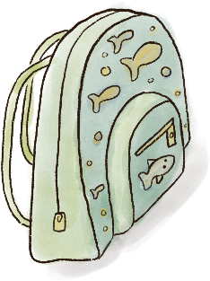
MyGov access rules limit the way support can be offered to families—either by calling the Centrelink support line or having a trusted person sit side by side through the process. Practitioners spoke about the need for better ways to support families.
“It would be great if there was a line providers could call to get quick answers from Centrelink so we can help families trying to apply.”
—Practitioner, Fairfield, NSW
“You can’t get work without childcare and you can’t get childcare without work.”
—Practitioner, Fairfield, NSW

The progressive pre-filling of information and standardising data requirements would reduce the burden on parents and practitioners
Many parents said they were asked for the same information multiple times on different enrolment forms, both online and on paper. While parents expressed their strong need to be in control of their information at all times, they also described bouncing between Centrelink and the preschool or CBDC to provide hardcopy documents and the same information repeatedly.
We heard that many families struggle to find and provide birth certificates, and the cost involved makes doing so unaffordable for many families. We were regularly asked why birth certificates are not simply issued at birth and instead require parents to apply and pay for them, as well as why they are not digital.
There is an opportunity to explore how the enrolment process could be improved to empower parents to selectively share data to make it easier to enrol in early learning services. This could be achieved by standardising data requirements or allowing parents to opt-in to information sharing between agencies, such as Centrelink and a central enrolment service.
“Every local government area has a slightly different enrolment process, a different form and a different way of registering. When families move from one municipality to another, the system is unfamiliar to them. There isn’t a standard (computer) system for record keeping, so tracking movement is very difficult. And then services have a different form as well—all of this could
be standardised.”
—Practitioner, Brimbank, VIC
“I think there are a lot of forms. Every single thing we do has paperwork. Unfortunately, it’s due to all the policies and procedures. I don’t see this changing; we are having to get parents to sign things all the time.”
—Practitioner, Bendigo, VIC
“I want to speak to a person—the robo-services are alienating.”
—Parent, TAS

Some families need one-to-one help to get through the enrolment process
In each location we visited, families experiencing vulnerability valued having someone they could trust to help them navigate the system. This support is often provided by practitioners, who described sitting with parents while helping them complete paperwork and access MyGov and Centrelink, as well as speaking to Centrelink on their behalf.
Practitioners often provide support in their own time, and doing so is outside the scope of their role, particularly in smaller centres with fewer staff. At times, educators fill in forms on parents’ behalf.
Other service providers, such as social workers and caseworkers, also assist parents and advise them on important dates. The ability to plan ahead was identified as a barrier for many families. When experiencing significant challenges, such as homelessness or family violence, it is difficult to pay attention to enrolment dates and plan ahead.
“Many vulnerable families think in the here and now. So truly vulnerable families miss out on spots as you need to enrol a year in advance.”
—Practitioner, Dubbo, NSW

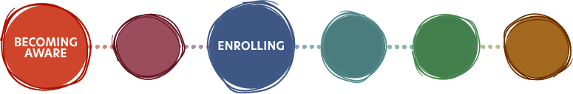

Practice Example: Brimbank notional kindergarten registration, Victoria

Purpose
Brimbank City Council in Victoria offers families ‘notional kindergarten registration’ for babies born in the municipality. Here, MCH nurses speak with families and register them at the nearest kindergarten to their home. Early registration enables councils to get in touch with families as their children are approaching preschool age and can design communications to engage families in decisions around preschool. This is funded and supported by the Victorian Government’s Central Enrolment Policy, which provides funding and best practice guides to support councils to centralise preschool enrolment in their area.

Possible impact
This proactive approach ensures that children do not inadvertently miss out on preschool due to their parents’ lack of knowledge about key dates. It also allows the council to ensure they have an appropriate number of spaces for children in the local government area. Receiving messages from a trusted source, such as an MCH nurse, makes families more likely to act on it.

Limitations
There will always be families that move in and out of areas or change their contact details; therefore, this may not be a comprehensive approach for reaching all families. All families can also register for preschool online.

More information
https://www.brimbank.vic.gov.au/childcare-and-education/kindergarten
https://www.education.vic.gov.au/about/educationstate/Pages/central-enrolment.aspx

Feeling welcomed and valued
ECE is not only about learning—it also contributes to the child’s social, emotional, physical and cultural wellbeing and development. All families need to feel welcomed and valued at preschool services for their children to fully participate and gain the benefits of early learning. We heard that ECE educators with a non-judgemental and welcoming approach were more likely to keep these families engaged. Families from culturally and linguistically diverse backgrounds must feel that their culture is respected, and families with children with disabilities and complex needs will benefit from reassurance that the early education environment is supportive and inclusive. Some ways that services can support families’ wellbeing are by ensuring staff have time to build relationships with families, allowing two-way conversations between families and practitioners about the children, and by connecting vulnerable families to services, including food programs.

What we heard

Families place value on the quality of the interactions they have with practitioners
We heard that the relationship between the preschool educator and family is crucial to children’s ongoing participation in a preschool program. We heard positive stories of educators and families building trusted relationships based on a shared interest in doing what is best for the child.
“We have a non-judgmental attitude. We have the [child’s] best interest at heart and show that we’re here to help. We help [the parent] to access free childcare full time. Offering that support and being aligned in common interest of the child.”
—Practitioner, Bendigo, VIC
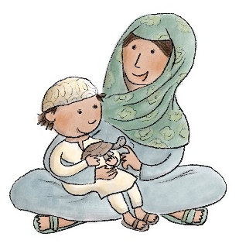
It was important to parents that educators approached them in the spirit of a shared partnership that valued the knowledge the parent brings and the expertise that the educator brings.
“Teachers need to understand our problems and have a relationship with us. They should be positive and they need to understand cultural difference.”
—Parent, Fairfield, NSW
“You have to give a bit of yourself to get something back.”
—Practitioner, Dubbo, NSW
“Here, everyone is accepted. I can be myself. There is no judgement.”
—Parent, Glenorchy, TAS
It was crucially important for parents that they did not feel judged by educators, as feeling judged was perceived as highly damaging to the relationship. Sadly, we also heard that many parents had had their trust broken by educators who were unapproachable, judgemental of the domestic situation, or who lacked patience or kindness. Such perceptions could be compounded by parents’ own memories of traumatic school experiences.
“Sometimes there are teachers that talk down to you and it makes me feel depressed.”
—Parent, Dubbo, NSW
“It’s hard to let your child go to someone you don’t like.”
—Parent, Wellington, NSW
The capacity of educators to build these trusted relationships varies significantly and may depend on the level of resourcing and training in working with families that is available.

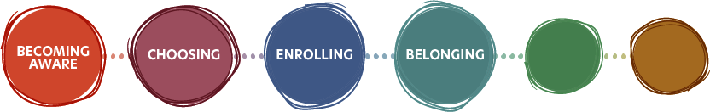

Practice Example: Off to an Early Start program, Bendigo, Victoria

Purpose
Developed by Communities for Children (C4C) Bendigo, the Off to an Early Start (OTAES) program recognises that participation in early learning programs is a key protective factor for at-risk children. Program mentors provide practical assistance to families through home visits to educate parents on how to get children ready for playgroup and preschool on time and attend on a daily basis. Mentors also work closely with preschool educators to help the families enrol and maintain attendance.
“Kinders have been amazing at accommodating and making special arrangements for these families.”
—Practitioner, Bendigo, VIC

Possible impact
The program helps parents overcome barriers, such as mental health issues and domestic violence, which may prevent families from sending children to preschool and childcare.
This ensures that vulnerable children do not miss out on early learning experiences. The intensive program is tackling “the last 5%—the too hard basket.” (Practitioner, Bendigo, VIC). A 2017 evaluation of the program indicated it was reaching a highly vulnerable target group and had high levels of client engagement.

Limitations
The casework is highly intensive and can require significant amounts of time per family.
“It took me one and half months of phone contact to help a mother build the confidence to just go see a daycare centre. I attended the first few sessions with the parent, and the director was amazing helping with all the forms, and now the parent has decided to enrol her child.”
—Practitioner, Bendigo, VIC

More information
http://www.c4cbendigo.com.au/projects/ off-to-an-early-start-project/

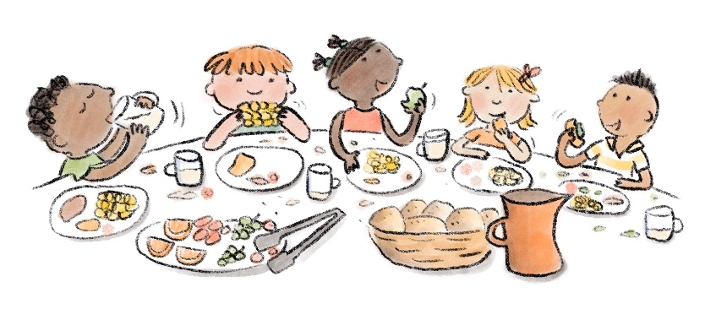

Educators can build trust with CALD families by understanding and including their culture and language
Recent immigrants and families from CALD backgrounds, as well as Aboriginal and Torres Strait Islander families (discussed in the next section) must feel that their culture is understood and welcomed and that they will not be discriminated against.
Families value seeing diversity in the people who care for their child. For example, we heard some centres proactively employ Aboriginal and Torres Strait Islander staff, which helps build trust with Aboriginal and Torres Strait Islander families.
Families must be provided with information in their preferred language, where possible. We heard that preschools struggle to access interpreting and translating services, as they cannot access the Translation and Interpreting Service for free, and their capacity to pay for translation services may be limited.
Many parents thought that having ‘food days’ or celebrating cultural events at preschool with a shared meal would help build stronger relationships between parents and practitioners. Children would also benefit from learning about different cultures and trying new foods. We heard about creative approaches to using shared meals to learn about different cultures.
“One centre had a large refugee population and they were not familiar with sandwiches. These families were often isolated and came from awful backgrounds and didn’t know anyone, so the kinder set up a working group for mums to make food together for the kids—rice and meals—and the kids would share that at lunchtime. So, the mums were connected through food and the kids were comfortable eating the foods from home. All the kids were eating that food. It was an informal approach. They got someone locally to donate the rice and did a fundraiser to purchase ingredients.”
—Practitioner, Bendigo, VIC

Food insecurity is a problem for many families living with disadvantage…
Concerns about food security were raised by families and practitioners in every location we visited. We heard that many families cannot afford fresh, healthy food on a regular basis. To address this, some service providers use food banks and gardens to provide free food for families.
“We always get fruit and veggies, and we have a fridge for frozen things, too. We use this for our food-share program and make up meals for families to take dinner home. We have a couple of families who we give dinner to every night.”
—Practitioner, Bendigo, VIC
We heard that some parents enrolled their children after finding out about preschool through a food share program. For some families, the food share program was a reason to keep turning up to preschool with their kids.
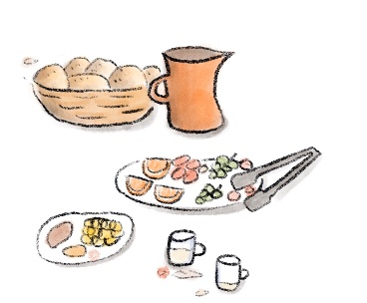
“One family comes to kinder with their kids on the same days the food bank is on. They started coming because their neighbours told them about the food bank program. This family had a baby with [Down Syndrome] and another 18-month-old. Her kids had never been to kinder before, and then they enrolled.”
—Practitioner, Bendigo, VIC
Many CBDC services provide meals to children in the preschool program, as they are already set up with kitchens and food systems. Parents are comforted to know their children will receive a healthy meal each day, and this is an important benefit of attendance. However, this option is not available to many parents due to the extra cost of CBDC.

…and packed lunches can be a source of anxiety for many parents
Standalone preschools do not provide meals, however they often keep snacks and food on site in case families forget to pack a lunch for their child.
The need to provide a packed lunch for preschool sessions is a barrier for many families. Families who are unable to provide a healthy lunch may feel stigma and shame. CALD families may be unfamiliar with local food options and feel judged for the food they provide. Early childhood services could think about how they can support families in feeling more confident when providing food.
“The lunches are a factor that so many people don’t think about it with an external kinder. Australia is unique in putting so much emphasis on packed lunches. I worked in London and it was never discussed. In Australia, it is so painful to need to pack lunches.”
—Practitioner, Bendigo, VIC
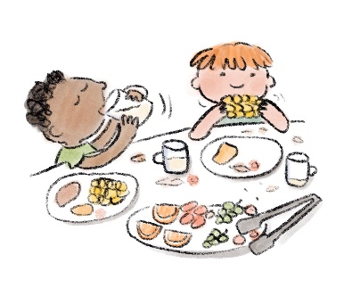
“Preschools need to be clear about what can go into the lunchbox. I was so upset when my daughter brought her lunchbox home with a note on her packet of chips saying this has 1mg too much salt. And I bought them from the health food aisle!”
—Parent, Fairfield, NSW
We also heard that having to provide a lunchbox could actually prevent attendance.
“We had a case where a child wasn’t attending, so I wanted to understand why. I spoke to mum and she said she didn’t have enough food, so she didn’t send the child. Mum was feeling a lot of shame and embarrassment. So, we reassured her and set up a plan where she would bring an empty lunchbox and the teacher would fill up the lunchbox and no-one else in the room would know. Now they can sit at the table with their friends and have their lunchbox and look the same as everyone else.”
—Practitioner, Bendigo, VIC
“We definitely have more attendance on the days we have the food share.”
—Practitioner, Bendigo, VIC

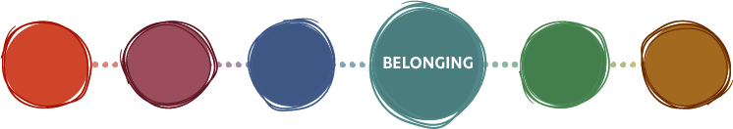

Practice Example: Preschool garden at Havilah Road, Bendigo, Victoria

Purpose
Havilah Road Preschool received a healthy heart grant in addition to a small amount of local council funding to upgrade their vegetable garden. The educators installed three wicking beds and began incorporating gardening into the educational experience. The aim is to provide a healthy source of food and nature-based learning for children and increased engagement for parents.

Possible impact
Havilah Road Preschool’s garden is a demonstration of nature-based play working well. An educator told us that the garden has not only enabled nature-based learning but has also facilitated learning about math and science, stating, ‘not only are the children learning about growing, nutrition, etc., but we are also learning about math. We measure rainfall in the water gauge, measure the size of beans as they grow, and hypothesise about changing colours linked to readiness of the fruit’. The benefits of nature-based play for children, educators, and families are supported by a large amount of research (Knight, 2009) (Elliott & Chancellor, 2014). The benefits to children include increased confidence and motivation and social, physical, imaginative and language skills (Gill, 2011) (O’Brien, 2009).

Limitations
Not all centres have sufficient sunlight and space for growing gardens, so this may not be possible for all preschools. This approach also requires teachers to be trained in nature-based pedagogy, and there may also be difficulty accessing funding for gardens, which is not universally available.

More information
https://earlyyears.ymca.org.au/centres/HavilahRoad

Preschools can be a key touchpoint in identifying disabilities and developmental delays early and
providing support
We know that early intervention leads to better outcomes for children with disabilities. Families want to know that their children are well prepared for school, but there is stigma associated with a disability diagnosis. This creates a tension that many families find difficult to resolve, particularly those who are newly arrived in Australia or who are unfamiliar with the range of early intervention support available.
“There is lots of shame culturally for families with children with additional needs. Parents don’t engage with services because of this shame, and then the first time these kids are known is when they show up to school.”
—Practitioner, Fairfield, NSW
“Disability is perceived to be the ‘fault’ of the family—either something they did, or something in their genes, either way, it is their ‘fault.’ Other families might be in pure denial that their child has a disability.”
—Practitioner, Fairfield, NSW
Connecting families living with disadvantage to community and allied health services can promote healthy child development.

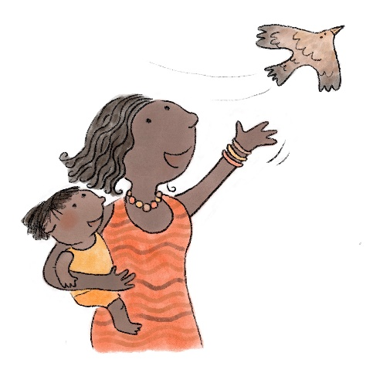
Feeling respected and culturally safe
In our workshops with a group of Aboriginal peoples in outer regional NSW, families considered cultural safety a crucial factor. If parents did not feel that an early learning service was culturally safe, this was a barrier for both enrolment and ongoing attendance of their children. We learned that passing down cultural knowledge and practices, connecting to communities and involving Elders in children’s learning were critically important for these families. While this section focuses on cultural safety for Aboriginal and Torres Strait Islander peoples, cultural safety is also an issue for multicultural communities. Experiences of racism and discrimination are detrimental to ongoing participation, and we heard that ECE services must be non-judgemental, active, open to embracing cultural diversity and able to provide information in community languages.

What we heard

Cultural leadership of preschools enables a strong ECE model that responds to Aboriginal and Torres Strait Islanders children’s needs
In Wellington, we heard Aboriginal voices who spoke from experience about the benefits of an Aboriginal owned and run preschool. Teachers and Elders described how the preschool was sensitive to local people, social situations and culture. Benefits of the preschool included no fees, Aboriginal educators, trauma-informed practice, a school bus and a focus on building connections with each child’s family. Some families travelled up to 50 km with their child to attend the Aboriginal run preschool rather than attending a local service. Educators told us about the importance of trauma-informed practice training.
“Trauma children need consistency… more than safety, it is comfort and security.”
—Aboriginal Early Childhood Teacher, Wellington, NSW
“Not charging fees has made a difference to enrolment and attendance. The preschool is full already for the next year.”
—Aboriginal Early Childhood Teacher, Wellington, NSW
Creating an appropriate environment is an important aspect of cultural safety, and building such an environment is most effective when done by people of the same culture as those whom the service is aimed towards.
“Feeling comfortable about the place; good environment; feeling safe, if you are comfortable, your children will be comfortable.”
—Aboriginal Parent, Wellington, NSW

Enabling cultural safety includes fostering a living culture that is connected to identity, place and people
In preschool environments that are not culturally safe, judgement and fear are major barriers to enrolling and attending. As a pre-condition to enabling cultural safety, preschools must have a strong sense of a living, meaningful culture, connected people, and a sense of community, history and place. A strong culture is needed to build trust with families and ensure a sense of safety for children.
“Cultural practice, learning. It’s child and family centred. It matters. It’s important. It’s roles and responsibilities. It’s men’s business and women’s business. It’s inclusive. It’s belonging to friends and land. It’s continuing and evolving. It’s truth. It’s a holistic approach. It’s sharing our knowledge. It’s trust and it’s knowing.”
—Aboriginal Workshop Participants, Wellington, NSW
Building a strong culture is more than adopting a document or strategy; it means having people who are part of Aboriginal and Torres Strait Islander cultures and communities within the school.
“Culture is everyday living.”
—Aboriginal Elder, Wellington, NSW

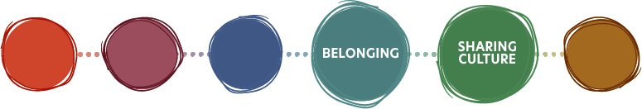

Practice Example: Balee Koolin Bubup Bush Playgroup, Cranbourne, Victoria

Purpose
The Balee Koolin Bubup Bush Playgroup provides a culturally safe pathway to engagement in early learning for Aboriginal children and families through weekly playgroup sessions. The playgroup is held in the Cranbourne Botanic Gardens and is co-facilitated by Aboriginal educators from the partnership organisations. Cultural guidance is provided by local Aboriginal Elders.

Possible impact
The playgroup embeds culture into practice and, in doing so, encourages cultural identity and connection. The playgroup activities include parental engagement in active nature play, the sharing of cultural stories and learning languages in a bush setting. Along with their cultural impact, these activities provide health and wellbeing benefits. The initiative was recognised as a finalist in the 2020 Victorian Department of Education and Training Victorian Early Years awards (Department of Education and Training Victoria, 2020). Research has noted the benefits and impact of Forest preschools internationally, and nature play and bush play in Australia (Elliot, 2018).

Limitations
This model is not explicitly promoting regular attendance at preschool, and there is no data to say if the cultural safety of this group makes families more open to ECE.

Facilitated by
This is a partnership between Casey Cardinia Libraries, Royal Botanic Gardens Victoria and the Victorian Aboriginal Corporation for Languages.

More information
https://www.rbg.vic.gov.au/learn/early-childhood-excursions/balee-koolin-bubup-playgroup/

Community connections embed the preschool in wider Aboriginal and Torres Strait Islander cultures and build trust
We heard that it is important for educators and staff to build strong relationships with families and their communities and have an awareness of each child’s family context. If the family is experiencing challenges, the educator needs to be aware of the situation and be understanding and non-judgemental. Each child should be cared for in this context.
“Culture is really important (at this preschool). But what makes it possible is that we’re all Aunties.
—Practitioner, Wellington, NSW
“It’s an open relationship. We would rather know if the family have had a fight the night before. They trust us, but it takes a long time to build that trust. And so, when they go to other public schools, they have to just fit in.”
—Practitioner, Wellington, NSW

There are challenges transitioning from a culturally safe preschool to mainstream schools
We heard reasons why the mainstream education system does not work for Aboriginal and Torres Strait Islander children. For example, children moving into a bigger system may no longer feel cared for. To improve cultural safety and participation in mainstream schools, the Aboriginal workshop participants made a range of suggestions.
“They need to learn the history of the local community, not just the general Aboriginal history of Australia.”
—Practitioner, Wellington, NSW
“We need to educate our teachers. Most of our teachers have never met a contemporary Aboriginal person... We need to change how they feel, to make it affirmative, so they are proud to be teaching Indigenous culture… Unless you have a teacher who is passionate about Aboriginal culture, then it doesn’t happen.”
—Practitioner, Wellington, NSW
An ECE practitioner stated that the curriculum and academic work is less important for Aboriginal people:
“The mainstream is about going to school and getting grades. Whereas I just want my children to be happy… we need to teach kids to be strong, resilient and adaptable, so they can face the school system.”
—Educator, Wellington, NSW
“You can’t have a culture embedded unless it is affirmative practice. We spend so much time on doing this stuff, and then the wonderful work that is created just sits in a document, but it doesn’t go into action. So, we need to put things into affirmative, positive practice. We need everything we do to be living the culture.”
—Aboriginal Early Years Practitioner, Wellington, NSW

Practice Example: Dubbo West Preschool, NSW

Purpose
Dubbo West Preschool is a standalone centre that provides a high-quality program (Exceeding National Quality Standards), innovative approaches, wrap-around services and systems to continuously measure program effectiveness.
Dubbo West has a strong reputation in the local Aboriginal community and is known as a safe place. Over 30% of the 240 children enrolled are Aboriginal. The preschool employs five Aboriginal educators and has integrated the teaching of language and culture into the design of its education programs. The service prioritises children of Aboriginal backgrounds for places and offers a playgroup to prospective enrolments. Funding allows the centre to provide a bus service, employ additional Aboriginal staff members and run a mental health and social program for the children.

Possible impact
The preschool has strong attendance rates, and these data are collected via a mobile app. In one reporting period, the attendance rate was 95%, with the remaining 5% having explained absences. The preschool has mechanisms in place to record concerns identified so that the necessary steps can be taken to address them. Students’ numeracy and literacy progress is tracked, and the results of Aboriginal and non-Aboriginal children can be compared. The service prepares children to be as independent as possible and ready for the transition to
primary school.

Limitations
The preschool acknowledges that some families in the Aboriginal community are difficult to engage, particularly families that only spend a short time in Dubbo. This funding is provided by government and is not available to most preschools.

More information
https://www.dubbowestpreschool.com/

Participatory decision-making with Aboriginal and Torres Strait Islander people would help integrate cultural safety within ECE
Ensuring that cultural safety is present in any ECE service requires involvement and participation in decision-making by those most affected. To increase the participation of Aboriginal and Torres Strait Islander children in ECE, participants were clear that staff, families and community representatives must have a seat at the table.
“If we’re talking about fixing the education system then we need a seat at the table.”
—Practitioner, Wellington, NSW
“Community and partnerships: You don’t make decisions ‘about’; we need to make decisions ‘with’. We need to make us leaders of our own business.”
—Early Years Practitioner, Wellington, NSW
“Listening to the kids, giving them a voice.”
—Educator, Wellington, NSW

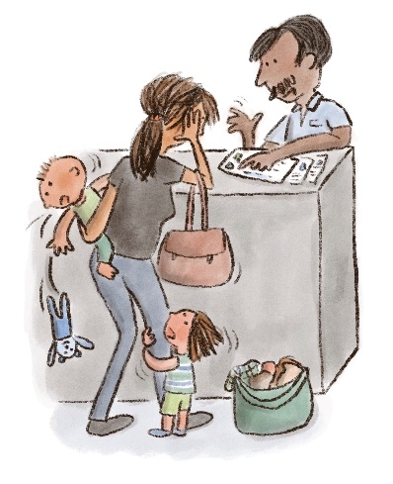
Being offered support
Families experiencing disadvantage often have a range of intersecting needs due to factors such as mental health, disability, family violence and homelessness. We heard that there is no ‘one size fits all’ solution in these contexts and that, in fact, the complexity of these issues is only increasing. Some families need support to send their children to preschool and this is only possible when there is trust for the educators and a degree of collaboration between educators and support services to meet the family’s needs.
Building these relationships can be complex, challenging and time-consuming. We heard that many educators know the value of this work and how it benefits children and families, but they often lack the time, training and resources to engage effectively. We heard that when practitioners can spend time with families and are aware of local support services, they can help families stay engaged with early learning more effectively.

What we heard

Educators need time and training to build relationships with vulnerable families
Educators are well aware of the importance of good relationships with vulnerable families in ensuring continued engagement with early learning education for their child.
“Relationships are the absolute foundation. The cornerstone of everything. It makes the whole experience better with the child. Especially with vulnerable families, it can take an incredibly long time to create that trust.”
—Practitioner, Bendigo, VIC
While larger ECE organisations may have the scale and resources to dedicate professionals to outreach roles, many standalone preschool programs and smaller centres do not. This means that family outreach is often conducted in the educator’s own time, if at all. We heard that some educators went the extra mile, such as preschool teachers who stayed late to call families who were not attending and a number of centre directors who would walk children to and from preschool to ensure they attended when their parents were struggling to cope.
“We really have to maintain connection in order for the kids to maintain attendance.”
—Practitioner, Bendigo, VIC
To perform this work effectively, educators also require training and support to learn how to work with increasingly complex family issues. Practitioners spoke of the need to understand the impacts of trauma, disability and other forms of disadvantage to support families.
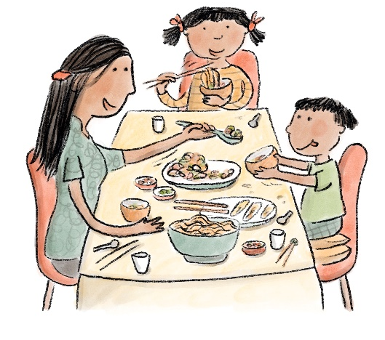
“The ‘accidental counsellor’—the role you end up playing in some families’ lives is much more than a teacher role.”
—Practitioner, Bendigo, VIC
“Every person there is there for the right reason, it’s more than a local network. There is care. We are not there for ourselves we are there to build a strong commitment for the community.”
—Practitioner, Dubbo, NSW

Practice Example: Lightning Reef Early Learning Centre in Bendigo, Victoria

Purpose
The YMCA Lightning Reef Early Learning Centre is a purpose-built early learning hub co-located within a local primary school in Bendigo. The hub was designed to bring together education, health and child development services to be more accessible to the local community.
The hub offers an integrated CBDC service and preschool program, as well as a maternal and child health (MCH) nurse and an Enhanced MCH service on site. For additional flexibility, Lightning Reef offers childcare before and after preschool session times at a small fee to provide parents with the option of longer sessions. The primary school out-of-hours care programs are held at the centre, which allows siblings to interact and provides a single point for larger families to collect their children. The spaces are also used by the community for playgroups and events, and rooms can be used by specialists.

Possible impact
With the high rates of disadvantage in the area—approximately one-third of enrolled families experience one or more vulnerabilities—Lightning Reef offers a valuable local resource that allows families to attend to their children’s education and health needs more easily.
A key strength of Lightning Reef is the relationships of staff with child protection workers and support services in the area. Often, families are referred to the centre by caseworkers, as childcare can be a protective factor for children at risk. These families are often entitled to full fee coverage under ACCS funding. The education leader describes how the team have a strict focus on the wellbeing of the child: “For us, it’s about driving the best opportunities for those children”. Lightning Reef has established itself as a trusted figure for families. “We provide support to families experiencing domestic violence and other challenging situations—and often once a child is no longer under child protection they stay with us.”
Being co-located with the MCH service means that nurses can walk families over to the counter to explore enrolling their child in childcare and preschool. These warm referrals are crucial for families who need support to engage with services. We heard that preschools and other CBDC centres make use of the hub by referring families to the health services on site; therefore, the benefits extend beyond the direct local area.

Limitations
While there are many benefits for local families and children, physical infrastructure like integrated hubs is costly to build. It is good practice to include the community in the design and decisions about services to be included, and this adds to the time and complexity of the undertaking. The current Victorian strategy is to build such hubs in areas of high need. Larger centres like hubs also benefit from having dedicated Centre Directors who can manage relationships with caseworkers and support families during enrolment.

More information
https://childrensprograms.ymca.org.au/early-learning/lightning-reef
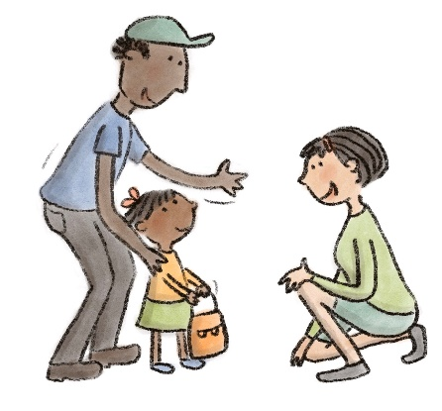

Educators can play a key role in connecting vulnerable families to other
support services
We heard that when trust is established, parents consider ECE practitioners to be an important family relationships. We heard that educators work hard to build that trust with a strengths-based approach.
“We have a non-judgmental attitude, have the child’s best interest at heart, and show we’re here
to help.”
—Practitioner, Bendigo, VIC
“We have trauma children who have drugs and alcohol, parents in jail, domestic violence that’s going to affect them mentally and physically.”
—Aboriginal Early Childhood Educator, Wellington, NSW
While many parents described negative interactions with ECE practitioners, and a general distrust of authority is a significant barrier for many families, for many parents, their child’s educator was a trusted and respected source of information. There is an opportunity to ensure educators are supported in their work with families.
“Often, we get families settled [into preschool] and then there is a crisis down the track—and because of the relationship we have established they will come back to us.”
—Practitioner, Fairfield, NSW

Families benefit when early childhood educators collaborate with local health and community services
and schools
In response to the increasingly complex needs of families experiencing disadvantage, we heard that educators and service providers are developing formal and informal networks to collaborate to support families.
“The families we are seeing have become significantly—in fact, dramatically—more complex over the last 10 years. We’re seeing extensive family violence, and a lot of parent mental health issues.”
—Practitioner, Bendigo, VIC
“I really like when there are other services involved, so other service providers can work on the family violence and I can work on enrolment and kinder. Sometimes the issue is bigger than I can handle so I’ll call Family Violence Service and meet with people to create a case and triage process to collaborate.”
—Practitioner, Bendigo, VIC
We heard that service integration in physical hubs or in local networks can bring practitioners together to support them and help them work together where needed. Ongoing, collaborative relationships between practitioners working with the child and family could even be a
protective factor.
“We had a child who was an empathetic ball of love but suddenly is now hitting others and being anti-social after witnessing a family violence incident. So, we’re doing a communication book for his caseworker and parent.”
—Practitioner, Bendigo, VIC

In particular, the relationship with the MCH service was considered a key relationship that encourages families to connect with their ECE providers. At times, families, particularly those experiencing vulnerability, need ‘warm referrals’, that is, they must be personally introduced to the service in order to engage. Providing these families with a phone number or paper referral is unlikely to be acted on. Practitioners are able to facilitate these referrals, particularly in co-located services, through introductions, follow-ups and even, in
one case we heard about, by attending specialist appointments with the family to support
the consultation.
“A lot of allied health appointments and services would have fallen through for those families if it wasn’t within that [Hub] building.”
—Practitioner, Bendigo, VIC
“From a practice point of view, where you have MCH and educators co-located, there is a lot of informal, anecdotal information sharing. There can be a shared sense between practitioners of working on shared goals with families, particularly where children have developmental delays or disabilities. They can work together on how messages are delivered to parents. A teacher might talk to the nurse about sending the family back to do the 3.5-year-old check and raise whether that has happened and whether they could get the MCH nurse support to facilitate sharing that information. That would keep parents
engaged and, on a pathway, where they were gaining more knowledge about their child’s needs.”
—Practitioner, Bendigo, VIC
In Bendigo, we heard about an event at which ECE educators meet with prep teachers to personalise the transition process. As well as providing Transition Statements, the ECE educators also talked to the primary school about the children who would be attending Foundation (the first year of school in Victoria) the following year to ensure that the children had the best possible start, with support put in place where needed.

Practice Example: Evidence for Learning, Social Ventures Australia

Purpose
Evidence for Learning (E4L) is a national not-for-profit which supports educators to implement evidence-based practices in education, particularly for children surrounded by disadvantage. The Teaching and Learning Toolkit (for schools) and Early Childhood Education Toolkit are freely available on the E4L website, and provide accessible summaries of research “to support great practice to become common practice”.
In addition to the toolkits, E4L offers webinars and workshops to help educators to embed these practices and get the best possible outcomes
for children.

Possible Impact
When working with children experiencing disadvantage, educators are looking for interventions that will have the highest possible impact in order to help those children catch up with their peers. The toolkits allow educators to find those practices and explore trade-offs between impact, cost and evidence quality related to those practices. The ECE Toolkit is mapped to the National Quality Standard, which helps educators to contextualise the evidence base into frameworks they are familiar with.

Limitations
The Toolkits do not make definitive claims as to what will work to improve outcomes in a given setting. Rather they provide high quality information about what is likely to be beneficial based on existing evidence. E4L has noted that there are currently less resources available for early childhood educators compared to those for school teachers, and due to the keen interest from early learning practitioners, they are working to provide more high quality, evidence-based resources for the ECE sector.

More information
https://evidenceforlearning.org.au/the-toolkits/early-childhood-education-toolkit/all-approaches-full-toolkit

Practice Example: School Readiness Funding, Victorian Department of Education
and Training

Purpose
The School Readiness Funding model from the Victorian Department of Education and Training (DET) is an innovative policy approach to building capacity in funded three and four year old kindergarten services. DET has developed a clear and easy to use ‘menu’ called the ‘School Readiness Funding Menu of Evidence-Informed Programs and Supports’. It provides more than 120 evidence-based programs, supports and resources for services to choose from, including a social worker or family support worker, staff training in trauma-informed practice, cross-cultural awareness training and coaching.
Available since 2019 in targeted areas of disadvantage around the state, funding is now permanently available to all Victorian services offering funded three- and four-year-old preschool programs, including within CBDC centres. Funding is allocated based on the level of need, which is informed by Student Family Occupation and Education data and can range from $1,000 to more than $200,000 per service.

Possible impact
The menu allows Victorian preschools to tailor their services to better meet the needs of local families and communities. Each item on the menu is linked to a priority area:
- Communication (language development).
- Wellbeing (social and emotional).
- Access and inclusion.
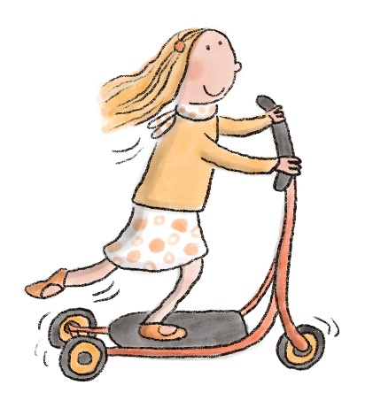
Structuring funding around these activities helps preschools ensure that they target those important needs, in particular for families and children experiencing educational disadvantage. The menu framework also allows DET to evaluate the link between funding and impact more accurately. As part of the funding agreement, services are asked to acquit their funding by reflecting on outcomes. DET is also developing a monitoring and evaluation framework to guide the development of the program.

Limitations
This approach is currently only available in Victoria.

More information
https://www.education.vic.gov.au/childhood/providers/funding/Pages/SRFmenu.aspx

As the number of children with complex needs rises, educators struggle to meet the needs of all children
Many families with children with disabilities and those impacted by trauma reported difficulties accessing supported places in preschools. This could relate to the capability of the service as well as to the individual concerns of the parent for their child.
“I’m not confident that kinder will meet my child’s needs.”
—Parent, Brimbank, VIC
Early intervention services are also difficult to locate. Even after the implementation of the National Disability Insurance Scheme (NDIS) in 2013, services are either unavailable, difficult to access or not promoted.
“Very hard to get into the speech pathologist. It took my son two years to get funding because they said that it depends on the school too. It is really hard. There are waiting lists and you have to wait for the funding.”
—Parent, Fairfield, NSW

For preschools, meeting families’ complex needs is increasingly difficult. Due to staffing and time challenges, practitioners struggle to make time to have conversations with families.
“The best way to work with young children is to work with their families, and we just don’t have time to engage with families.”
—Practitioner, Brimbank, VIC
Distressingly, the project also heard stories of children being excluded from preschool. Nevertheless, these stories were substantially outnumbered by families who described their appreciation for quality programs that promote inclusion and wellbeing.
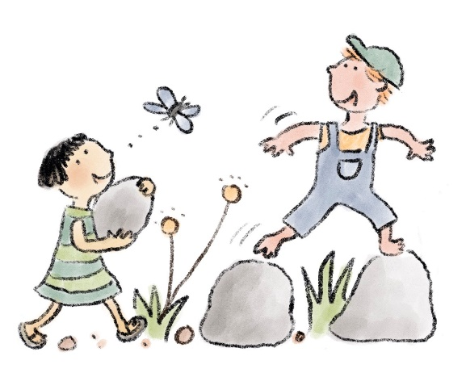
“When the kids love the teacher, they want to go to preschool. They feel safe and secure. The teacher needs to give the parent a secure feeling. If you feel your child is unhappy, then you can’t be happy.”
—Parent, Fairfield, NSW

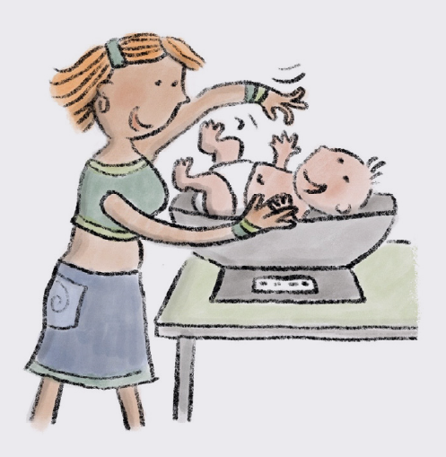
Family story: Jane’s Story
In 2017, Jane brought her then six-week-old son, Nate, to a ‘Kid’s Day’ event in Willmot that was facilitated by The Hive. Over the following year, Jane attended other community events and was connected with a family caseworker from one of The Hive’s Collective Impact partners. Working with her caseworker, they identified preschool as a key goal for Jane’s family. Jane had previously enrolled Nate in several other centres in the area but had not sustained any of these placements for more than a few months. In early 2020, Jane’s case worker introduced Jane to the early learning team at The Hive and helped her to get enrolled.
The first step involved the Early Learning Linker, Kylie, who helped Jane identify which CBDC were accessible to her and suited to her unique circumstances and priorities. Kylie also worked with Jane to apply for both the Child Care Subsidy for her younger son, who had not yet attended childcare, as well as the Additional Child Care Subsidy (Transition to Work) based on her full-time study. This allowed Jane to receive more subsidised hours of care for both her boys. Once Jane had chosen a centre, The Hive supported her in completing enrolment, including printing immunisation records, dropping enrolment forms at the centre and covering the one-off enrolment fee.
Over the course of 2020, The Hive continued to support Jane in sustaining the placement. Due to Jane’s hearing impairment and intellectual delay, Kylie would act as a ‘middle-man’ to help resolve miscommunications between Jane and the centre. For example, Jane did not feel confident in communicating via phone and would at times be left confused after in-person discussions with the director of the centre. In these situations, Jane would reach out to Kylie to clarify and re-communicate. Other misunderstandings related to the day-to-day care of the boys, such as if one of the boys was sick or if clothes were changed during the day. When such misunderstandings occurred, some mediation was needed to reassure Jane that the centre was following best practice and that her concerns were being heard by the centre management. Jane has also received ongoing support in understanding the fee structure and invoicing patterns of the centre and has had frequent communication with The Hive throughout the year to feel confident staying on top of her account. This has, at times, involved Kylie meeting both Jane and the director at the centre to clarify an invoice or to discuss a strategy for payments to avoid having fees in arrears.
Jane has been able to sustain enrolment for both her boys for over nine months, despite the challenges that arose during the COVID-19 pandemic, which is the longest period Jane has remained with any one childcare centre.

Case study: The Hive, Mount Druitt NSW
The Hive uses a collective impact approach to support families experiencing deep disadvantage in engaging with ECE. Their vision statement is ‘All children in Mount Druitt start school well’. They have demonstrated that building trust, often over long periods, is essential for working in this community. Consistent, holistic and tailored assistance delivered in a non-judgemental way is essential for families experiencing multiple barriers to early education enrolment and attendance.
Up to 30% of children in Mount Druitt do not attend preschool prior to starting school. (AEDC, 2018b) Many more children do not reach the 600 hours of preschool agreed by COAG as a national priority due to patchy attendance and late enrolment. The Hive was formed to tackle this deep-seated problem. It began with action research that involved walking alongside families to understand the barriers they faced in accessing early education. The initiative has adopted a try, test and learn approach. Deep community engagement and concrete improvements for children and their communities are central to the team’s work. Over time, the ‘Early Learning Linker’ role was designed to offer the 1:1 support needed to local families.

The Early Learning Linker is a qualified social worker who adopts a ‘whatever it takes’ approach to secure enrolment and maintain preschool participation for families in Mount Druitt. This includes:
- Assisting families in processing late birth registrations and birth certificate applications and using brokerage funds to cover the cost
where needed.
- Providing computer access to, for example, complete online forms, obtain Immunisation History Records, or locate other services such as health and allied health services.
- Supporting families in their interactions with Centrelink and ensuring that they receive the correct Child Care Subsidy and understand Additional Child Care Subsidy eligibility.
- Identifying suitable quality vacancies to meet child and family needs, such as transport, with extra capacity to support children with additional needs.
- Completing enrolment documentation.
- Paying bond and other upfront enrolment costs.
- Supporting families in managing the payment of fees and building rapport with services so that problems can be discussed.
- Helping families manage when they fall behind on payments and have fees in arrears.
- Providing general advocacy support.
The Hive’s primary target group are families that do not engage with the service system and thus that are not already receiving support. Working with local partners to develop regular community-based events with low barriers to entry, the team focuses on building relationships with families. Sidestepping the formal referral pathway by using social media and SMS has encouraged families to build trust and
make contact.
Staff take a trauma-informed service approach, giving patience, time, encouragement and flexibility. Providing pragmatic and agile support, such as transport to Centrelink, and conducting warm referrals to local food support services for struggling families has enhanced relationships and trust.

More information
https://thehivemtdruitt.com.au/

Part 2 – Solutions from the community
We asked parents and practitioners what they thought would help improve preschool enrolment and attendance. Each location had its own strengths and challenges and varying levels of capacity to meet the goal of enabling every family to send their child to preschool.
In each location, we encountered families and practitioners with strong views on how to better meet the needs of families in their communities. Although each community had a unique perspective, there was also significant agreement across communities on what is not working.
While we focus on place-based solutions, some concepts have larger systemic policy implications for policymakers to consider.
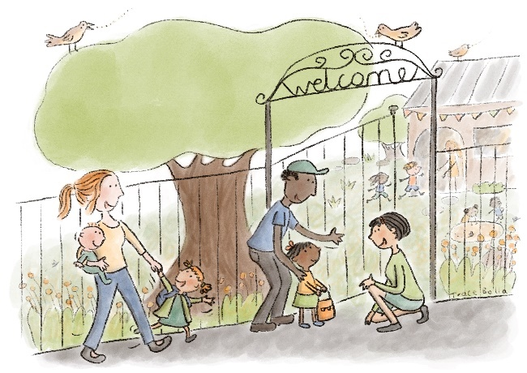

Ideas from the community
The parents and practitioners who participated in the project worked collaboratively to generate ideas to address the barriers to participation in preschools in their communities. These raw ideas are presented here to generate opportunities for further development.

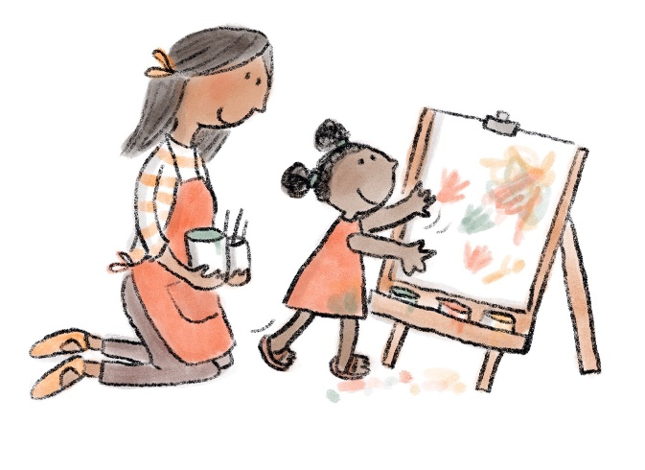
Understanding the benefits of preschool
Outreach
Employ a ‘linker’: a person who has time to work with families and build trust. ‘Get out there!’
Outreach
Make home visits where possible to welcome and engage the community.
Raising awareness
Include information on preschool in the Bounty Bags at hospital.
“People read that stuff.”
Messaging
Helping parents to understand the value of preschool. “It’s just not a priority.”
Raising awareness
Services, such as Centrelink, could encourage parents to enrol and provide more information on available subsidies.

Finding the right preschool

Cost
Fund early learning in the same way as public school education.
Cost
Offer free spots (no out of pocket costs) for disadvantaged kids.
Cost
Align funding between preschool and Centre Based Day Care so that families can access full days around preschool hours.
Choosing a preschool
Create a matching service to match families to the right centre for their needs.
Universal policy
More consistency between states.
“It has to be across the board. Even if you move, it has to be the same for everybody.”
Flexibility
- Offer more flexible hours. “Why can’t kinder be run all day so that parents can just check in or check out whenever it suits them?”
- Families in crisis need flexibility.
Transport
- Ensure preschools are accessible by public transport.
- We need a bus to and from preschool.
- Noticeboard at service about help regarding pick up/drop off.
Bond
Do away with the bond payment in certain centres.
Subsidies
Ensure preschool subsidies are available to all parents, regardless of visa status.
Subsidies
Provide extended ACCS funding beyond 13 weeks for some families. Families must repeatedly apply through the year.
Subsidies
Address the perception that parents must say their child is at risk in their care to receive the ACCS (child wellbeing) funding.
Subsidy information
Provide more clarity on the financial support and subsidies available to families. Currently, this is too ad hoc.

Having a simple enrolment experience

Digital systems
MyGov is confusing because the ID number is different to the CRN for Centrelink and in MyGov you can get immunisation statements but not birth certificates.
Birth certificates
Parents shouldn’t need to pay for birth certificates. Find another way to verify the child’s identity.
Child record
- A digital education record for each child.
- Allow data sharing between Centrelink and Births, Deaths and Marriages to confirm children’s identity.
Enrolment
- Simplify enrolment forms.
- Communicate key enrolment dates to families.
- One form for all permissions at preschool.
Enrolment support
Create a Centrelink support line for practitioners to enable them to help families who are struggling to enrol.
Digital enrolment
- Create a portal with information for parents to make it easier
to enrol.
- Ensure enrolment forms can be completed on mobile phones.
Enrolment helper
Centralised enrolment point for all centres in the area linking parents to their preferred centre and helping with paperwork and
computer support.
Community
Orientation days at preschool to build relationships and help new families enrol.
Transition to school
Data sharing with schools so that the family finds school
enrolment easier.
Standalone preschools
More places for families looking for preschool (rather than long
day care).
Enrolment systems
Make preschool enrolment opt-out rather than opt-in (from Bendigo).

Feeling welcomed and valued

Workforce diversity
- Increase Aboriginal and Torres Strait Islander educator and staff employment.
- Employ culturally diverse staff.
Workforce diversity
Identify strategies to combat stereotypes to increase male employment in early learning.
Community events
A range of activities that are inclusive of various cultural backgrounds to make ECE centres a safe and welcoming space.
Children’s voices
Structured weekly interaction enabling children to voice their goals, vision and desire for learning, followed-up by a commitment
to implementation.
Parent engagement
Inclusive activities to engage parents in ECE centres.
- Workshops with Elders.
- Cultural lunches.
- Coffee mornings.
- Playgroups.
Screening
Put a three-year-old check in place for any medical or developmental issues to be picked up before reaching school age.
Curriculum
Include ‘Wellbeing’ within the curriculum as a prioritised and measured learning objective.
Communication
Practice deep listening, inclusivity and non-judgement and
remain informal.
Feedback for parents
Make it easier for parents and educators to make contact.
Workshop for parents
Parenting skills and healthy eating workshops led by Aboriginal and Torres Strait Islander Elders.
Follow up support
Early intervention for non-attendance.
Disability support
Help parents find centres that provide help for children with
complex needs.
Communication
Simplify the information provided to families by making it less wordy and easier to understand.
Community
More opportunities for families and practitioners to engage with
each other.

Building trust
‘Observation rooms’ that allow anxious parents to look through a large window to see how their child is settling in.
Cultural events
- Cultural awareness days.
- Provide ways for children to learn about different cultures and ways of life.
Feedback for parents
- Access to the day-to-day progress of children in preschool.
- An app to see what the children did during the day.
Milestones
Expand the Childhood Early Development Book to track social and skills milestones.
Accessibility
Every preschool should have accessible ramps for children
in wheelchairs.
Inclusion
More services for children with special needs. Preschools to be
more supportive of children with a disability so they can be part of
the mainstream.
Environment
- More outside play.
- Plenty of space for children.
- Homely, inviting centres.
- Be welcoming to parents.
Inclusion
- More disability specialists supporting children.
- Teach Auslan.
Multicultural support
- Free, easy access to quality interpreters.
- Multi-lingual parent groups.
- Employ bilingual staff.
Food security
- Food share programs.
- More partnerships with appropriate services, including
food banks.

Feeling respected and culturally safe

Transition to school
- Transition program to support Indigenous children into school.
- Design pathways and communication channels for schools to care for and nurture children.
Cultural safety
Create cultural safety awareness in mainstream schools regarding the re-traumatisation of Stolen Generations.
Cultural safety
- Cultural learning is informed by cultural practice.
- Culture must be central to the curriculum.
Cultural knowledge
Implement ‘Cultural Knowledge Pass’ programs to ensure knowledge transmission and build resilient, proud Aboriginal and Torres Strait Islander peoples.
Policy
- Recognise community agency and autonomy in
policy decisions.
- Ensure policy translates into action.
Curriculum
- Preschool executive staff require commitment to translate curriculum into cultural actions.
- Valuing the centre’s cultural philosophy on par with curriculum.
Cultural safety
Include learning on Aboriginal and Torres Strait Islander language to support history, culture, identity and confidence.
Community and culture
Local practices to support culture include cooking, music, dancing, toolmaking, storytelling and visual art.
Educator training
Preschool educators need better cultural competency training to deliver Indigenous education.
Flexibility
Flexible environment to meet CALD and Aboriginal and Torres Strait Islander needs.

Being offered support
Evaluation
More evaluation of what works.
Support
There is a disconnection between ECE services and allied health or community service workers. A community of practice or regular catch ups could be helpful.
Home resources
- Online programs for children who cannot come to preschool.
- Activities for home.
- Home connection in to preschool.
Connections
Practitioners must create connections with other services to enable responsive support for families experiencing vulnerability.
Community engagement
- Involve the community more in activities and events.
- Have an open day every term.
- Fun days and events.
Support
Ask, “How can I help?”

Community concepts
From the many ideas generated in our workshops, we asked participants to prioritise one or two to take forward. We prototyped and tested these ideas with the community to learn how specific solutions might work.
While each solution requires further exploration and validation, we outline the core needs and goals in detail and have included specific actions to take them further. Each concept must be tested at a local level and then trialled and evaluated. If found to be effective, they can then be scaled.
It should be noted that while these ideas were identified and prioritised in the communities we worked in, other ideas might be
prioritised elsewhere.
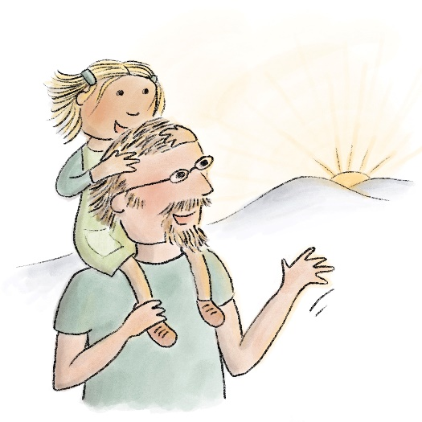

Community Concept: A local communication campaign, Bendigo, Victoria

Overview
This concept is a local communication campaign that helps parents understand the value and benefits of ECE for their child. The prototype explores how relevant practitioners and trusted community members could align on key messages to ensure that parents hear consistent information at service touchpoints over time.
The target audience is parents with children up to age four, along with their friends and other family members, to lift broader community expectations around preschool. Increasing understanding of the long-term benefits of preschool is likely to lead to increased engagement and attendance for the hard-to-reach families.
This approach could be supported by a national strategy, as practitioners spoke about the value of national leaders, such as politicians and sports players, both men and women, also lending their voice to the campaign.

Aims
This concept requires a coordinated series of messages from trusted professionals at key stages in the child’s life. The aims are:
- To increase awareness and understanding among families of the value of ECE.
- To engage local health, community and education sectors to align on messages about the benefits of ECE for children, families and
the community.
- To test and develop messages that work to change behaviour.

The problem
Families experiencing disadvantage face many obstacles to their children’s participation in preschool, many of which are related to awareness, attitudes and circumstances.
While most families are aware of ECE, many are unaware of the range of benefits to parents, children and to the broader community or do not prioritise it due to life chaos or cultural beliefs.

Place based context
Bendigo has a high rate of preschool attendance, with approximately 97% of children enrolled in a kindergarten program (AEDC, 2018a). One of the reasons we chose Bendigo as a site for further exploration is that the community has achieved this high rate despite significant rates of socio-economic disadvantage.
Through our research in Bendigo, we found there are several programs and services targeted to families experiencing family violence and mental health issues, and notable collaboration between practitioners in order to link families to services more effectively.
In our workshops and interviews we heard that a local campaign could help parents to make preschool a priority. We explored how practitioners could support parents to be aware of and value their children’s preschool education in the context of the many other challenges these families are facing.

Local communication partners
- Maternal child health nurse. Key practitioners who can build awareness early through an interaction that is trusted and
universally available.
- Doctors and other primary health workers. Could add value by communicating messages about ECE in the context of healthy
child development.
- Family support worker. Could communicate the benefits of ECE to parents and address doubts and uncertainties relating to enrolment.
- Liaison officer. A person who understands government policies relating to subsidies, enrolment and ECE services who can communicate the clear benefits of and procedures surrounding enrolment to parents.
- Allied health and early intervention specialists. Some families may have greater contact with Early Childhood Intervention Services within the NDIS.
- Community leaders. Local communities have different community leaders depending on place and cultural context.

Age of the child to receive communion
- Birth to one year of age. The time spent in MCH nurse visits, playgroups and mothers’ groups is a key time to build awareness of the value of ECE. This is currently part of the MCH and EMCH practice in Victoria; therefore, there is an opportunity to unify language and expand to other services where this may not be standard practice.
- One to three years of age. The ideal enrolment time for three-year-old preschool is halfway through the year prior; therefore, messages about enrolment deadlines and processes would help normalise proactive planning.
- Three to four years of age. To enrol in time for four-year-old preschool, parents must be informed when their child is three years of age in the year prior. Clear communication from early childhood educators, family workers and others would aid a timely enrolment process.

Messaging and language
- Responsive and adaptive messages. Primary barriers to ECE and drivers of participation vary depending on person and place. For this reason, we suggest that communication strategies include verbal messages that can be adapted for particular people and contexts.
- Messages that work. The science is clear about the benefits of early childhood attendance, but messages about evidence alone may not be effective.
“The messaging needs to be presented very sensitively, and very carefully so that it doesn’t come across as suggesting that the parents are not capable of meeting their own child’s needs.”
—Practitioner, Bendigo, VIC
We must include messages about benefits for parents as well as children.

A local communication campaign that helps parents understand the value and benefits of ECE for their child.
Age | Birth | Age 1 | Age 2 | Age 3 | Age 4
Application |  |  | Apply for 3 year old kinder | Apply for 4 year old kinder | Apply for primary school
Key  messages | MCH Nurse: Early learning is so important during the first five years of a child’s life. Childcare can be a great support for parents too. There is lots of help available to get enrolled. I can connect you to a service that will help you with the process.  Mothers Group: It’s great to connect with other mums and learn something from the info sessions too. | Doctor: 90% of a child’s brain develops in the first five years. Preschools and childcare centres can be a great support for families. Have you thought about enrolling? I can refer you to a service that will help you get started. | Family Support Worker: Early learning centres can support your family in many ways. Your child will learn new skills and make friends. Parents can have some time to themselves. We can help you with the cost too. Here are some options to look at. Can I help you to find the best centre for you? | Liaison Officer: Is your child enrolled in early learning yet? Preschool helps your child get ready for school and now is the time to enrol. Can I help you? | Early Learning Educator: Welcome! Let me show you around. Feel free to come back and continue the conversation. We’re here  to help.  Liaison Officer
Description | MCH nurse provides information on the importance of early learning for the development of the child and for parental wellbeing. Later on, a doctor highlights the importance of childcare and preschool. |  | Parent receives targeted verbal communication from service workers explaining the benefits of early learning services for both the child and parents. | Liaison officer calls parent for a chat to ask if they need help deciding which preschool is best for them and offers support with sourcing documents understanding fees and completing forms. | Liaison officer calls parent for a chat to ask if they need help deciding which preschool is best for them and offers support with sourcing documents understanding fees and completing forms.

Design considerations
Influencing attendance rates is a complex challenge that will require multiple strategies to move the dial. During our testing, we were advised that complementary measures with shared aims will be needed for this campaign concept to work. A new integrated public early learning liaison officer who understands State and Commonwealth policy would aid with local communication campaigns. Similarly, communication campaigns on enrolment will not work if the enrolment process and cost barriers are not addressed; awareness is one of a many of aspects involved in promoting active participation.

Recommended actions
- Validate the campaign in other areas. This prototype was developed in Bendigo—a municipality with a high level of enrolment in early learning services. Given the high enrolment levels, we recommend validating this campaign in communities with lower levels of enrolment before selecting a trial location and subsequently scaling in other target areas. We recommend user testing with experts who work with target parents across two other locations.
- Design a trial campaign for implementation. Assuming there are no substantial changes to the Bendigo model, the steps to design a trial are as follows:
- Design formal messaging and trial processes, as well as confirm approach, budget and providers.
- Develop an implementation plan using implementation theory and evidence.
- Establish a collaborative working group of local organisations who have trust among target communities and who agree to be delivery partners. Trust and credibility within the community is important to transmitting messages effectively.
- Work with existing stakeholder groups and their programs of communication and coordination.
- Develop content and a delivery medium for distributing to partners, such as a digital script that is purposive and usable, including objective, key messages and target user groups.
- Set up data collection and feedback processes to ensure the trial is measured, adaptive and effective.
- Allocate budget for an evaluation of the trial and prepare to share the results on completion.

Community Concept: An Early Childhood Education App, Fairfield, NSW

Overview
This concept is a smartphone app that brings together information on the local early education system, subsidies and personal information to support easier enrolment. A digital tool will allow families to track their child’s development and connect them to services more responsively.

Aims
A digital tool that can:
- Provide local, personalised information to parents on preschools, including enrolment deadlines, place availability and specialisations.
- Support families with preschool enrolment and provide subsidy information.
- Offer useful early childhood development support.

The problem
Throughout the project, we heard that finding and processing all the information that families need to access preschool is difficult. Families are already exhausted by the time they make it to the door of the preschool, which impacts their first experience of preschool.
At present, there is no single source of information for parents because the sector is complex and difficult to navigate. To give children the best chance of achieving developmental milestones, including health and educational development milestone, we must make information and practical help easy to find.
Families talked about how the Blue Book provides this information for health needs, and that building on this approach could provide them with access to the information they need.

Place based context
The app concept was designed for families in Fairfield who struggle with the complexity of the system and experience difficulties managing the information requirements of enrolment and subsidy application.
Families in Fairfield, like families in many other communities, must spend considerable time navigating the health and ECE system. For example, if someone has a disability, the family must provide similar or repeated information to Centrelink, health agencies and the various centres they wish to apply to. There is no integrated service or platform that allows families to search for local services, navigate the information on different public services or submit applications.
We discovered that most parents and carers carry smartphones and use these devices to keep and retrieve records and search for information, including those who do not have computers or data access in the home. Based on these insights, we set out to develop an accessible app that delivers childhood development advice and information on services, subsidies and support.

This app will help untangle the confusion and provide a clearer pathway to preschool.
The concept behind this app is to complement the health department information provided to parents with early education information that is localised and individualised.
There is so much information available that it becomes easily confusing and alienating for parents already facing barriers, and unfortunately, services that are available are often not accessed by those who need them the most.

Alerts
Set alerts for important events such as preschool enrolment dates, health screening checks and term dates.

Document auto-fill
This function will assist with completing preschool application forms by pre-populating information so that it only has to be added once.

Share documents
Ability to share documents directly with the ECE provider by linking to an email account.

Record storage
Link to a secure file to store copies of important documents such as birth certificates, immunisation records and other identity documentation.

Fees and subsidy calculator
Calculator function that is programmed to provide information based on individual circumstances.

Location services
Search function that limits information to the local area to narrow down options.

FAQ
Frequently asked questions section moderated by a team with knowledge of the ECE services in the local area.

Record storage
- Information about educational milestones.
- Connections to local early childhood education services websites.
- Connections to government websites.
- Advice for parents.
- Age-appropriate activity suggestions.
- Useful contacts.

Design considerations
Families want to be empowered to find the right information for them. Most parents and carers, even those who do not have computers or data access in the home, carry smartphones and use this device to keep and retrieve records and to search for information. This concept is intended to complement the Child Digital Health Record (Baby Books) currently being trialled. Of course, complex problems require nuanced and locally targeted solutions. This prototype is intended to be part of a multi-pronged strategy.

Recommended actions
- Consider the ECE app as part of a wider approach. Consider this app alongside complementary solutions, such as a new independent early learning liaison officer who understands State and Commonwealth policy. Providing information in a range of ways would promote active participation.
- Continue user research and testing. Continue user research with various primary and secondary user groups to determine use
case requirements.
- Prior to building the app, develop an inter-government strategy to resolve issues and develop the app to diagnose barriers and resolve issues before developing the platform.
- Consult with the Australian Government app project digitising the Child Health Record (Baby Books) to understand how health and developmental information could integrate into the ECE app.
- Resolve barriers to information sharing across levels of government and ensure that various service providers can adhere to
technical requirements.
- Coordinate or integrate with other important network and sector information repositories and coordinating services, such as the Raising Children Network and Bright Tomorrow app.
- Develop a cross-department strategy on how information sharing, data storage and integrated service applications would work to develop a single mobile phone app.
Set up a digital product development process.
- Engage a cross-disciplinary product design team with a strategic designer, software developer and user experience designer and subject matter experts.
- Build wireframe prototypes and further user testing and product validation processes before developing a digital product and launching a trial.
- Allocate budget for an evaluation of the trial and prepare to share the results on completion.

Community concept: An enrolment helper, Dubbo, NSW

Overview
The ‘Enrolment Helper’ is a face-to-face service provided by trusted local professionals who help families to engage with early learning services. The ‘Helpers’ would focus on building long-term, positive relationships with families, educators and service providers. They guide parents through choosing a preschool service that suits the child and family’s needs, and then supports their enrolment and
ongoing engagement.

Aims
The enrolment helper service prototype aims to:
- Provide personalised guidance for families to help them understand where to enrol and support them in the application process.
- Remove barriers to enrolment and support families through the enrolment process.
- Create a positive first connection with families and ECE services.

The problem
Participation in ECE is limited by a range of barriers, including fear of judgement, financial cost and a lack of trust in government services.
In Dubbo, we heard that more families would participate in ECE if support was available to help them navigate the system. The families we spoke to described the need for personal support as they tried to find and enrol in a preschool service for their child. It was important to families that the service was independent from local preschool services so that the Helpers could be seen as neutral. We heard that the service must be staffed with trusted, local and non-judgemental members of the community.

Place based context
There are 20 ECE options in Dubbo, including six standalone and school-based preschools and 14 centre based day care centres (ACECQA, 2021). Knowing which type of ECE is suitable and has places available can be difficult to determine for families, particularly for families new
to Dubbo.

Helping families to navigate the local ECE system.
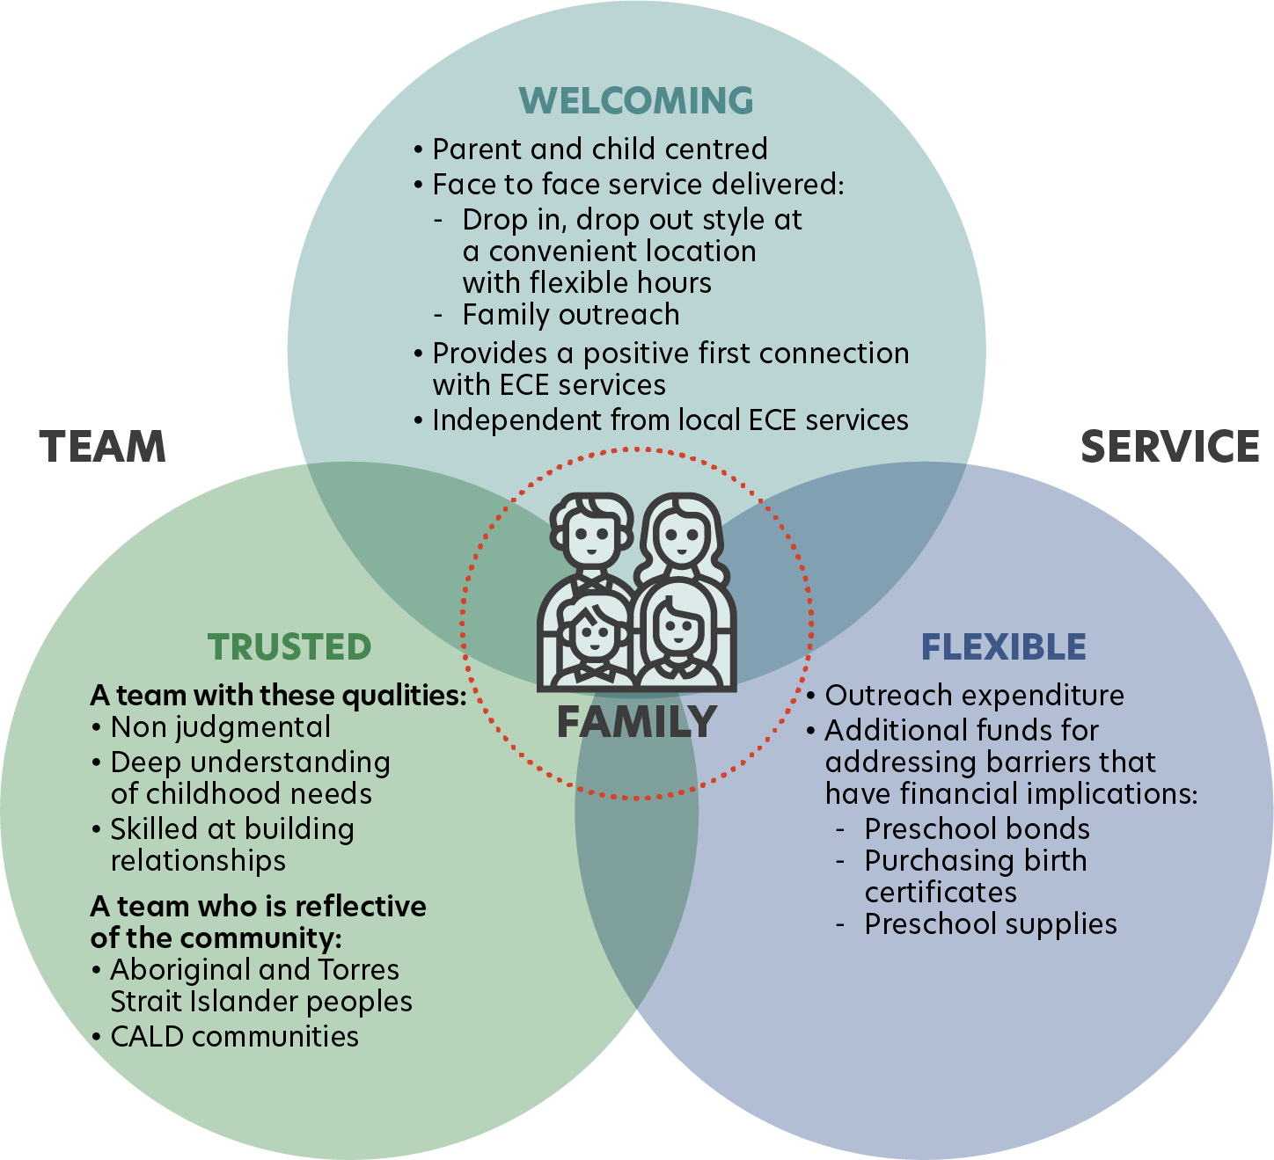

Pre-enrolment activity: Enrolment guidance and support
Support to:
- Understand the available options for ECE
- On how to enrol and the application process
- To remove any barriers to enrolment

Pre-enrolment activity: Family outreach
- Go where they are
- Target families experiencing barriers to engagement
- Starting point for building relationships, awareness and trust

Maintenance activity: Links to other services
- Health
- Safety
- Welfare
- Food Security
- Other

Maintenance activity: Follow up on child's progress and attendance
- Provide regular check-ins with the family about attendance
- Help to resolve issues if needed

Design considerations
Our user testing in Dubbo strongly indicated that the concept could increase engagement in early years education. Feedback from families, educators and early years practitioners was highly positive and discussed the inclusive and welcoming principle, the personalised advice and guidance, as well as the concept’s ability to remove enrolment and engagement barriers.
The barriers families experience in Dubbo are not unique, and the concept could be a model for other communities to work from and build on. Relatively little initial investment would be required to test the idea further, as investment in infrastructure is not necessary.

Recommended actions
- Prioritise recruiting the most suitable individuals. Identifying and recruiting appropriate staff is the biggest challenge in trialling the idea. Candidates must have a range of early years knowledge (education, welfare, allied health) and experience in connecting with diverse families and communities in Dubbo (e.g., migrant families and Aboriginal and Torres Strait Islander families).
- Develop a recruitment strategy. Position descriptions and a recruitment strategy should be created. The team could start with two people and slowly grow as the idea is refined.
- Build in capability and consider succession planning. It was acknowledged that there is a strong pool of workers in Dubbo with the necessary experience and connections to take on a role in this service. It was noted that there would be a need for a team with all the required knowledge and skills, rather than just one individual worker.
- Make relationships key. A success metric for this role is the helpers’ ability to create strong relationships with families and early
years practitioners.
- Develop a plan for trial implementation. We recommend that the idea is first trialled in Dubbo, as it was designed with and by the Dubbo community. It may be necessary to invest in training and skills development and allow time for the helpers to develop the necessary relationships and practices before the concept begins to generate tangible outcomes. It is likely that longer-term investment in development and testing (approximately five years) will be needed.

Steps to design a trial include:
- Establish a collaborative working group of local organisations who have trust among target communities and who will support and promote the enrolment helper concept across the early childhood and family support system.
- Extend or establish networks to ensure the enrolment helper service has connections with all relevant services in the area.
- Identify appropriate locations for the enrolment helper service. A neutral, independent space is important.
- Authorise formal messaging and trial processes, budgets, approaches and providers.
- Set up data collection and feedback processes to ensure the trial is measured, adaptive and effective.
- Allocate budget for an evaluation of the trial and prepare to share the results on completion.

Community Concept: A universal screener, Fairfield, NSW

Overview
This concept is a universal screening program that brings together health and education outcomes for all children aged three to four years to confirm that each child is on track developmentally and that connects families to the services they need.

Aims
The prototype allows preschools to better develop individual learning plans by aligning to the Australian Early Development Census domains to better meet the needs of children. The screen also aims to allow families to determine whether additional support is required and provide guidance on why early intervention is beneficial and where to access it. Most importantly, it must be available for all three-year-olds.

The problem
It is clear that early intervention for children at risk of vulnerability yields positive results. However, for many families, developmental assessments are perceived as unnecessary or stigmatising. For families that do not wish to undergo an assessment, finding the right support is difficult. To give all children the best chance of achieving their developmental milestones, we must make screening and practical help accessible, non-stigmatising and non-threatening.

Place based context
Rates of childhood disability and delay in Fairfield in south-western Sydney are above the state average. The benefits of an early intervention system for families in south-western Sydney would be greater than elsewhere because more families are falling behind in this area.
We heard that some residents of Fairfield feel shame associated with being identified as having a disability. In addition, some local medical practitioners do not encourage parents to have their children assessed until they reach school. For these reasons, it is unsurprising that many children start school with unidentified delays.
Based on these insights, we formulated a design question for locally relevant prototypes to respond to these issues: How can we design an early intervention system for families in Fairfield to increase awareness about developmental milestones and integrate health expertise with learning plans?

The universal screener brings together health and education outcomes for all children aged 3 to 4 years old.

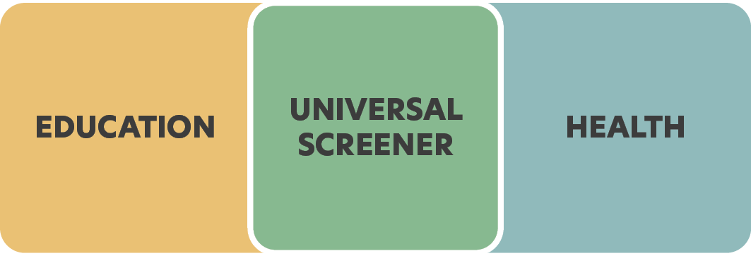
Universal screener purpose
- Connect families to early intervention support
- Provide information to families about local early education options
- Support preschools to better meet children's needs, including any additional needs
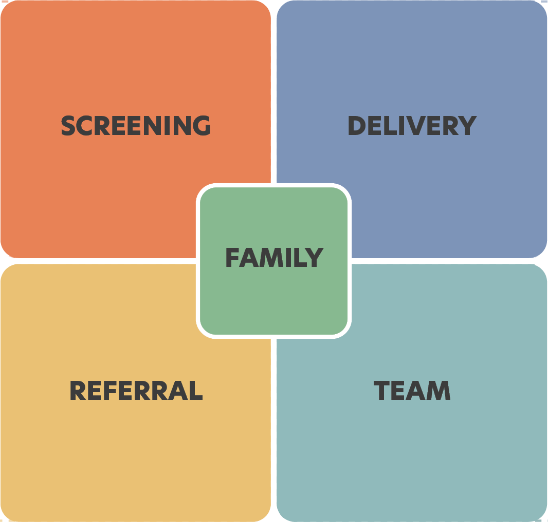
- Improve parental understanding of the links between early childhood health
and ECE

Key activities
Screening
- Broad screening of tracking against major developmental domains:
- physical wellbeing
- social competence
- emotional maturity
- general knowledge
- language and communication skills
- Documentation of screening outcomes for parents
Referral
- Information on services and support available in the local community that focus on parents, early years and preschool
- A 'Bounty Bag' for every child screened, containing a book, art and craft materials and activities (sensitive to cultural background)
- Warm referrals to ECE, allied health and other services

Key resources
Delivery
- A screening tool that allows for swift feedback.
- Guidance on how to proceed based on the outcomes
- Mobile setting for families that are difficult to reach
- Translation services
Team
- Appropriately qualified staff to apply the screening tool and help parents understand the additional supports (if any) that are required
- ECE experience is essential
- Local knowledge is highly important

Design considerations
At present, two screening programs are being trialled in south-western Sydney, where Fairfield is located. These programs are designed to use existing universal medical infrastructure—General Practitioners and Child and Family Health nurses—to determine developmental risk. Funded through National Health and Medical Research Council and NSW Health, respectively, knowledge of these trials has yet to filter down to the ECE community or the parents who took part in our design workshops or testing group. How these programs interact with education or design should be explored, and similar programs could be trialled in different states.

Recommended actions
- Explore existing screening trials in south-western Sydney. There is a growing appetite to improve the links between education and health systems. Families, particularly those experiencing vulnerability and disadvantage, require support to understand the connections.
- Identify whether features of the prototype could be incorporated into existing trials. The mobility of this service would maximise the chance of reaching families that are currently not accessing screening/assessment or ECE services. Ordinary, everyday settings would reduce stigma and fear and would ensure that even families with a deep mistrust of institutions could access the services they need. Further, offering an incentive in the form of a Bounty Bag would encourage families to engage with the screening.
- Explore strategies for bringing ECE expertise into the screening process. We heard that positioning education at the centre of screening is essential. This would ‘de-medicalise’ the process, reduce stigma and act as a powerful motivator for families wishing the best start for their child.
- Recruit suitable staff for the job. This should be a qualified early childhood educator who is familiar with early childhood development and enjoys interacting with children would support swift screening. The team should also be supported by an individual with knowledge of the local area, including ECE, allied health services and community support.
- Develop a plan for trial implementation. This concept was developed in Fairfield, a location that measures low on the scale of socio-economic advantage, which makes it an appropriate location for trialling the concept. The steps to design the trial are as follows:
- Authorise formal messaging and trial process, budget, approach and providers.
- Develop an implementation plan using implementation theory and evidence.
- Establish a collaborative working group of local organisations who are trusted among target communities and who will support and promote universal screening and use screening outcomes for individual learning plans.
- Extend or establish networks to ensure the screener has connections or pathways to connections with all relevant services in the area.
- Design a program of locations to ensure the highest possible accessibility and coverage for the area.
- Set up data collection and feedback processes to ensure the trial is measured, adaptive and effective.
- Allocate budget for an evaluation of the trial and prepare to share the results on completion.

Community concept: Sharing our Knowledge Approach, Wellington, NSW

Overview
The approach detailed in this Community Concept to Aboriginal family and community engagement is a practical guide for ECE services on ways of respecting culture and encouraging participation by Aboriginal children and families. This approach was built on from what we heard about the success of an Aboriginal led preschool in regional NSW. The tool aims to deliver a guided process for ECE services that results in cultural protocols tailored to each centre.

Aims
- Increase engagement and participation in ECE for Aboriginal and Torres Strait Islander children and their families.
- Build strong connections between mainstream ECE providers and local Aboriginal and Torres Strait Islander communities.
- Embed cultural safety for Aboriginal and Torres Strait Islander children and families into cultural protocols and actions of the ECE service.

The problem
Data indicate that Aboriginal and Torres Strait Islander children are being enrolled in preschool at rates consistent with population representation but that attendance is lower than that of the rest of the population (Productivity Commission, 2018) (ABS, 2016b).
Steps must be taken by mainstream ECE services to increase engagement and address the barriers to ongoing participation at preschool for Aboriginal and Torres Strait Islander children. Community connection, acceptance, cultural reflection and belonging are the most common factors identified as being essential to engagement in early learning for Aboriginal and Torres Strait Islander families (Old Ways, New, 2020).

Place based context
The concept of the ‘Sharing Our Knowledge’ approach was generated from insights gathered in workshops conducted on Wiradjuri Country in the outer regional town of Wellington, NSW.
The workshops were facilitated by the Indigenous design consultancy, Old Ways, New, with a group of Aboriginal Elders, community representatives, early years practitioners and parents.
During the workshops, the organisational ownership, pedagogy, staff practices and attitudes of an Aboriginal led preschool in the local area were repeatedly referenced. The workshop participants attributed the success of the preschool, which has high levels of participation and engagement of Aboriginal children, to the way the preschool was run.
This led us to ask the following question: ‘How can we utilise the learnings of the success of Aboriginal led preschools?’

The methodology
The Old Ways, New consultancy, who ran the workshops in Wellington, used their own ‘Country Centred Design’ approach, which utilises ‘Indigenous knowledges’.
Country Centred Design is explained as follows: ‘Our methodology is a cultural process, creating solutions for the needs of the environment, its systems, and the humans who occupy the spaces—real and virtual’ (Old Ways, New, 2020). The workshops placed importance on ‘understanding the stories of Wiradjuri Country and community, enabled through a two-way relationship’.

Key resources

The duration.
The process should take six to 12 weeks to complete from the first workshop engagement to the final delivery of the cultural protocols.
Facilitation.
External engagement is led by an Aboriginal and Torres Strait Islander person who is skilled and experienced in strategic design or community engagement, workshop facilitation and research reporting. The internal process will be managed by the centre director and will involve all the staff. It would involve the Traditional Custodians and create connections with local communities.

Connecting to curriculum.
This approach is suggested as the most beneficial for working alongside the Early Years Learning Framework that guides ECE services, preferably the ‘8 Ways Aboriginal Pedagogy’.

Cultural protocols: How to instill organisationally.
- Community connection, acceptance, cultural reflection and belonging were specified in the workshops and research as being important for Aboriginal and Torres Strait Islander children and families to engage with ECE services.
- The experience of belonging within ECE services varied depending on the presence of community connection, acceptance, non-judgement and cultural reflection, resulting in a spectrum of belonging.
- The approach will guide equitable and respectful relationships with the Aboriginal and Torres Strait Islander community in which the ECE service is situated and will help establish the service’s cultural identity and distinct way of being.

Key activities
The ‘Sharing Our Knowledge’ approach is centred on building the capacity of mainstream ECE services to develop cultural protocols specific to the area in which the ECE centre is located.

Community engagement.
- The first and foremost protocol is to connect with traditional custodians and Elders.
- The workshops should have at least 25% representation of the local Aboriginal and Torres Strait Islander community present, including the service’s executives, representatives, staff and parents. Ideally, this group of participants will become the working group and should be available for all four workshops.
- The process of engaging the local Aboriginal and Torres Strait Islander community to develop the Cultural Protocols is a central component of the process of bridging and building strong relationships within the community.

Workshops.
A framework for four practical sessions has been developed to assist ECE services in developing cultural protocols for their centres.
- Mapping Country and Kinship.
- Connecting to Country.
- Developing Cultural Identity and Cultural Philosophy.
- Translating Values and Principles into Cultural Protocols.
The illustration below shows a Wedge Tailed Eagle, the local totem animal for the Wiradjuri, Binjang Clan in the Wellington area. The words around the eagle are from the Aboriginal Elders, parents and practitioners connected to Nanima Preschool who participated in workshops for the project. These words describe what cultural safety and culture means to the community.
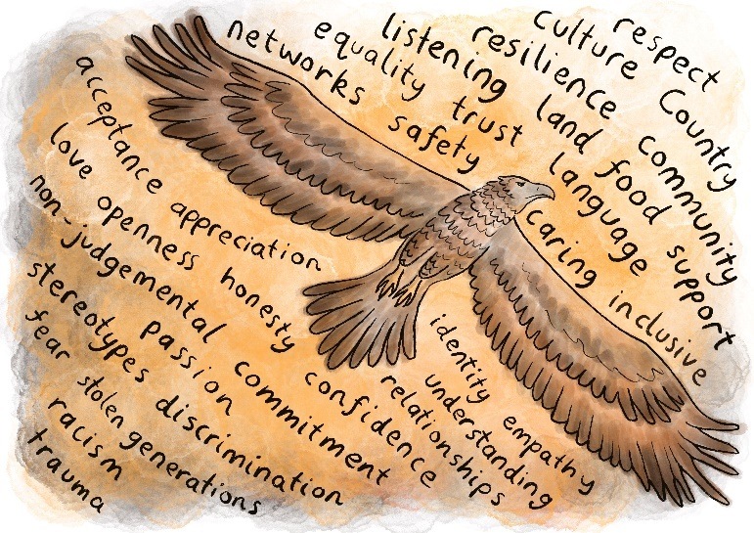

Design considerations
The approach has the potential to be locally developed in communities across Australia. Starting small by developing, validating and implementing a prototype version with a preschool on Country will allow value to be demonstrated before expanding the approach to other locations. Building relationships between preschool leaders and local Aboriginal and Torres Strait Islander peoples is the start of a powerful approach to making cultural protocols that embed Aboriginal and Torres Strait Islander cultures, ideas and people within mainstream preschools.

Recommended actions
- Test the concept further with the Aboriginal community in Wellington.
This concept is yet to be developed into a prototype. It is responsive to the messages received during workshops in Wellington, and we have received positive general feedback from the group, though it is yet to be thoroughly tested with community representatives or practitioners. An Aboriginal and Torres Strait Islander–run organisation would be best placed to lead this work.
- Test the concept in other locations. As the concept aims to mainstream ECE, we recommend testing it further for validation in locations with Aboriginal and Torres Strait Islander populations who access mainstream ECE services.
- Test the concept with other Aboriginal and Torres Strait Islander communities. The concept was designed based on feedback from Wiradjuri people. Aboriginal and Torres Strait Islander peoples are not homogenous, and it is important that broader views are tested to ensure transferability to other Aboriginal and Torres Strait Islander groups.
- Finalise design of the ‘Sharing Our Knowledge’ approach for implementation. Steps to design the trial include:
- Authorise the formal trial process and budget.
- Develop an implementation plan using implementation theory and evidence.
- Establish a collaborative working group of appropriately qualified organisations who have credibility and trust among Aboriginal and Torres Strait Islander peoples and the ECE sector.
- Develop a guidebook for Traditional Custodians and ECE services.
- Identify trial sites and partners.
- Set up data collection and feedback process to ensure the trial is measured, adaptive and effective.
- Allocate budget for an evaluation of the trial and prepare to share the results on completion.

Family story: Alex’s story
Alex was four years old when he moved to the small town of Wellington with a new foster family. He had moved through many foster homes and had been ‘kicked out’ of every early childhood education service he had attended. The foster family were at a loss. The family was referred to Nanima Preschool. ‘This was a child who was really traumatised, and the carers were about ready to send him back before it was recommended that they try the local preschool’. The director and educators at the preschool were able to provide much-needed support and understanding. In briefing her staff, the director emphasised picking up on the positive. Her message was ‘let’s not judge this child’.
The director worked with the carers to come up with a plan to address the barriers that Alex faced in participating in the preschool. Both carers worked, and while the limited days and hours of the preschool were an issue, the cost of centre based day care was prohibitive. Alex was offered a seat on the preschool bus, and extended family were rostered to look after Alex at the end of the day. The director liaised with another preschool in town to find a place for a further two days. A plan to deal with Alex’s behaviour was drawn up after observation of the triggers for his actions.
The director shared the plan and strategies with the other preschool so that there was consistency in the approach.
Alex was settled in within two weeks. ‘We have had no issues from day one because he is on Aboriginal land and he felt that connection’. He has now completed three terms and will transition to school next year. ‘He is a different kid’. The educators feel that, as soon as Alex walked into the centre, he felt a connection: ‘we are all Aunties. The culture was there for him. We cared and we wanted him to know that.’
The director stated, ‘we are not there just for the children. For us to help the kids, we need to help the family. We are community. For us to get the best out of the child, we need to get the best out of the family’.
For the director and educators at the centre, Alex is a success story: ‘this child was turned away from every service and yet we have had no trouble with him. It’s about putting that time into him and that care. Seeing what works and what doesn’t’.
‘He is our greatest success story. We wanted to make him succeed’.

Case study: Nanima Preschool, Wellington, NSW

Walking together to gather and educate
Nanima Preschool is on Wiradjuri Country in the small outer regional town of Wellington, Western NSW. Over a quarter of the town’s population are Aboriginal peoples. The preschool sits on the outskirts of town in Nanima Village, a former mission, and has provided the local Aboriginal community with access to early childhood education for over 45 years. There is significant pride and respect for the preschool, which has a reputation of being a ‘culturally safe and inclusive space that keeps neutral during times of volatility in the community’ (PwC Indigenous Consulting, 2018, p.3).
The Aboriginal–led and staffed community preschool has an ‘Exceeding National Quality Standards’ rating, full enrolment and strong attendance rates. In total, 98% of the children enrolled come from the local area and identify as Aboriginal.
In Wellington, 21.2% of children are assessed as vulnerable in at least two domains in their first year of school compared with 9.6% of all children in NSW. (AEDC, 2018b) Addressing the barriers to preschool participation is a priority for educators at Nanima, who take a holistic and early intervention approach in responding to the additional needs of children and their families. All staff have completed mandatory training and have further developed their knowledge and skills to be able to work with complex issues in a culturally sensitive way.
There are many practical examples of how Nanima tackles barriers to participation, including by providing a bus service, making preschool fee-free for parents, providing nutritional meals, employing Aboriginal staff, exceeding the required staff-to-child ratios, offering health checks onsite, connecting to allied health and partnering with community organisations. These extra services are possible due to additional state and Federal Government funding.
Nanima Preschool has an open-door policy that allows parents to participate in the preschool day and draws on the strengths of the community and expert cultural knowledge of the Wiradjuri people. Aboriginal cultures are embedded through the program design, such as in language lessons, a yarning circle and regular visits from Aboriginal Elders.
The community has hopes and dreams for the future of Nanima Preschool. They hope to see it continue to grow and develop, with an additional centre and extended hours to offer more flexibility.
Nanima Preschool demonstrates the impact of an Aboriginal owned and run model that is holistic and effective and integrated into the community and culture. While it may not be easy to replicate, lessons can be learned from the principles used by Nanima Preschool. If we prioritise, fund and promote similar innovative models, we will be making long-term investments in reconciliation, education and
economic development.

From the community
“It’s genuine. It helps that it’s located on an Aboriginal reserve. Automatically, you come down the hill, you’re on
Wiradjuri Country. It’s on a mission. And it’s populated with Aboriginal staff.”
—Aboriginal Elder, Wellington, NSW
“Nanima looks at every child, and their home life, and just gives them the best experience they can.”
—Preschool Director, Wellington, NSW
“I think Nanima is a good benchmark, not only for our community, but others across Australia.”
—Aboriginal Elder, Wellington, NSW
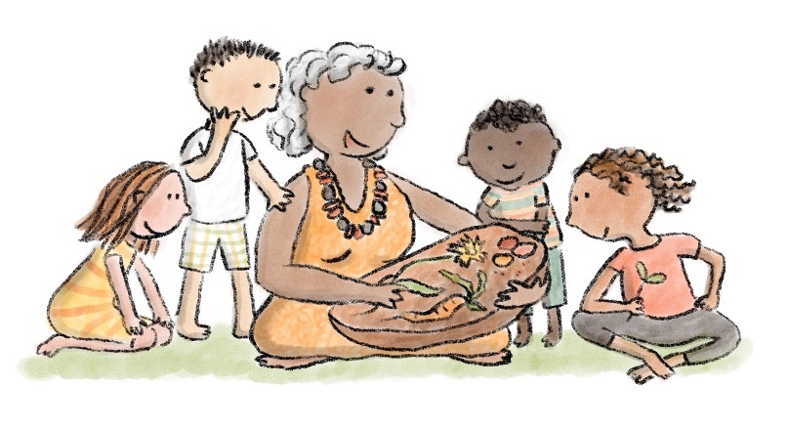
“The way in which Nanima values the philosophy not the curriculum is key. Give them the attributes and the skills,
rather than the A’s and B’s. We’ve flipped it on the head and asked, ‘How can we build the attributes rather than the
curriculum knowledge?’”
—Preschool Director, Wellington, NSW
“The community is blessed to have a preschool like Nanima here. I believe education is key to our community.”
—Aboriginal Elder, Wellington, NSW

Acknowledgements
The Smith Family conducted a range of interviews, consultations, meetings and workshops with families, communities, practitioners and other stakeholders connected to the Early Childhood Education sector. We thank all the following departments and organisations whose staff or representatives contributed to the project.

- Aboriginal Affairs NSW
- Aboriginal Land Council, Dubbo, NSW
- Allira, Dubbo, NSW
- Anglicare
- Austins Ferry Primary School, Claremont, Tasmania
- Australian Capital Territory Education Directorate
- Australian Children’s Education and Care Quality Authority
- Australian Government Department of Education, Skills and Employment
- Australian Government Department of Social Services
- Australian Government Department of the Prime Minister and Cabinet
- Australian Government National Indigenous Australians Agency
- Barnardos Australia, Dubbo, NSW
- Bendigo District Aboriginal Cooperative, Victoria
- Bendigo Education Plan, Kindergarten Working Group, VIC
- Big Fat Smile, NSW
- Bonnyrigg Public School, NSW
- Brimbank City Council, Victoria
- Brotherhood of St Laurence (HIPPY)
- Cabramatta Multicultural Family Centre, NSW
- Catholic Care Wilcannia-Forbes, NSW
- Connected Beginnings, Tasmania
- Department of Education and Training Victoria
- Department of Education Tasmania
- Department of Education Western Australia
- Dubbo Aboriginal Community Working Parties, NSW
- Dubbo and District Preschool, Dubbo, NSW
- Dubbo Regional Council, NSW
- Dubbo West Preschool, Dubbo, NSW
- Early Childhood Australia
- Early Learning and Care Council of Australia
- Fairfield City Council, NSW
- Fairfield Liverpool Supported Playgroups, NSW
- Fairfield Public School, NSW
- Future Tracks
- Global Access Partners
- Goodstart Early Learning, NSW, Victoria
- Gowrie Preschool, Dubbo, NSW
- Janice Crosio Early Learning Centre, Bossley Park, NSW
- KU Children’s Services
- Living Better Community Services, Dubbo, NSW
- Loddon Mallee Preschool Association, Victoria
- Meerilinga Young Children’s Foundation, WA
- Minderoo Foundation
- Mission Australia, Dubbo, NSW
- Moree Family Support, NSW
- Murdoch Children’s Research Institute, Victoria
- Nanima Preschool, Wellington, NSW
- New South Wales Department of Communities and Justice
- New South Wales Department of Education
- Ngala Child and Parent Centre, Calista, Western Australia
- Northern Territory Department of Education
- Nous Group, Australia
- NSW Service for the Treatment and Rehabilitation of Torture and Trauma Survivors
- Off to an Early Start program with Communities for Children
- Orana Early Intervention, Dubbo, NSW
- Orange Door, Bendigo, Victoria
- Playgroup Australia
- Playmates Cottage, Dubbo, NSW
- Queensland Department of Education
- Save the Children, Northern Territory
- School as Community Centres, Buninyong, Dubbo, NSW
- Secretariat of National Aboriginal and Islander Child Care
- Sector Publishing
- Shine Bright, Victoria
- Social Ventures Australia
- South Australia Department of Education
- Tagari Lia Children and Family Centre, Bridgewater, Tasmania
- Tasmanian Council of Social Services Inc.
- The Australian Centre for Social Innovation
- The Creche and Kindergarten Association Limited, Queensland
- The Front Project
- The Hive, Mount Druitt, NSW
- The Parks Community Network, Wetherill Park, NSW
- The University of New South Wales, Social Policy Research Centre
- The University of Queensland, Institute of Social Science Research
- United Way Australia
- Uniting, NSW, Victoria
- Three Rivers Regional Assembly, NSW
- United Children, Bendigo South, Victoria
- Victorian Aboriginal Education Association Incorporated
- Victorian Cooperative on Children’s Services for Ethnic Groups
- Vista Way Kindergarten Team, Wyndham City, Victoria
- Wellington Aboriginal Corporation Health Service, NSW
- Wellington Information and Neighbourhood Service, NSW
- Western Sydney University, Centre for Educational Research
- Wilmington Kindergarten, Wyndham City, Victoria
- Windermere Public School, Claremont, Tasmania
- Wyndham City Council, Victoria
- YMCA Lightning Reef and Havilah Road Long Day Care

References

ABS. (2013). The National Partnership Agreement on Early Childhood Education. Retrieved from Australian Bureau of Statistics: https://www.abs.gov.au/AUSSTATS/abs@.nsf/2f762f95845417aeca25706c00834efa/92D624C3B58990BBCA257C93000D0515?opendocument
ABS. (2016a). 2016 Census QuickStats: Wellington (NSW). Retrieved from Australian Bureau of Statistics: http://www.abs.gov.au
ABS. (2016b). Quick Stats Census Data. Retrieved from Australian Bureau of Statistics: https://quickstats.censusdata.abs.gov.au/census_services/getproduct/census/2016/quickstat/SSC11296
ACECQA. (2021). Find Childcare. Retrieved from Starting Blocks: https://www.startingblocks.gov.au/find-child-care/
AEDC. (2018a). Community Profile 2018 Greater Bendigo, VIC. Retrieved from Australian Early Development Census: www.aedc.gov.au
AEDC. (2018b). Data Explorer. Retrieved from Australian Early Development Census: https://www.aedc.gov.au/data/
AIHW (2019a). Youth Justice in Australia 2017–18. Cat. no. JUV 129. Canberra: AIHW.
AIHW (2019b). Child protection Australia: 2017–18. Child welfare series no. 70. Cat. no. CWS 65. Canberra: AIHW.
CESE. (2016). 5 Essentials for Effective Evaluation, Issue 14. Retrieved from Centre for Education Statistics and Evaluation: https://www.cese.nsw.gov.au/images/stories/PDF/5_Essentials_for_Effective_Evaluation_FA_AA.pdf
Department of Education and Training Victoria. (2020). Victorian Early Years Awards Finalists. Retrieved from Department of Education and Training Victoria: http://www.education.vic.gov.au
Department of Education, Skills and Employment. (2021). Universal Access Early Childhood Education. Retrieved from Department of Education, Skills and Employment: https://www.dese.gov.au/universal-access-early-childhood-education
Elliot, S. (2018). Understanding nature play in the context of bush kinders and the early years of primary school: What’s it all about? Nature Play Professional Development. Armidale: University of New England.
Elliott, S., & Chancellor, B. (2014). From forest preschool to bush kinder: An inspirational approach to preschool provision in Australia. Australasian Journal of Early Childhood, 39(4), 45–53.
Gill, T. (2011). Children and nature: A quasi-systematic review of the empirical evidence. London: Sustainable Development Commission.
Hubs Strategy Group. (2007). Setting the Hubs Humming. Hume Communities for Children Initiative. Fitzroy: Brotherhood of St Laurence. Retrieved from https://www.communityhubs.org.au/wp-content/uploads/2017/10/setting-hubs-humming.pdf
Jackson, J., Wolfenden, L., Grady, A., Lum, M., Leonard, A., McCrabb, S., ... Yoong, S. (2020). Early childhood education and care-based healthy eating interventions for improving child diet: a systemic review protocol. Systematic Reviews, 9.
Knight, S. (2009). Forest schools and outdoor learning in the early years. London: Sage Publications.
Laurens, K. R. (2020). Reading and numeracy attainment of children reported to child protection services: A population record linkage study controlling for other adversities. Child Abuse and Neglect, 101,
1–15.
Molloy C., Q. P. (2018). Restacking the Odds – Technical Report: Early childhood education and care: An evidence based review of indicators to assess quality, quantity, and participation. Melbourne: Murdoch Children’s Research Institute.
National Indigenous Australian Agency (NIAA). (2020). NIAA IAS Performance Report Jan June 2020 for Nanima Preschool. National Indigenous Australian Agency.
NDIS. (2020, September 30). Retrieved from National Disability Insurance Scheme: https://data.ndis.gov.au/data-downloads
Nous Group. (2020). UANP Review: Final Review Report. Nous Group.
O’Brien, L. (2009). Learning outdoors: The forest school approach. Education, 3–13, 37(1), 45–60.
Old Ways, New. (2020). Consultation Report for The Smith Family. Sydney: Old Ways, New.
Productivity Commission. (2018). Report on Government Services 2018 Part B, Chapter 3: Early childhood education and care and Chapter 4: School education. Canberra: Canberra: SCRGSP.
PwC Indigenous Consulting. (2018). Grant Activity Review, Nanima Early Childhood Children and Schooling Project. Canberra: National Indigenous Australian Agency.
SNAICC. (2021). Supporting Carers – Connecting to Culture. Retrieved from SNAICC – National Voice for Our Children: https://www.supportingcarers.snaicc.org.au/connecting-to-culture/cultural-protocols/
The Smith Family. (2019). Preschool Attendance Strategies Project – Interim Report. The Smith Family. Retrieved from https://www.thesmithfamily.com.au/-/media/files/research/reports/preschool-attendance-strategies-project-interim-report.pdf
The Smith Family. (2019, December). Preschool Attendance Strategies Project – National Research Report. The Smith Family. Retrieved from The Smith Family (2019) National Research Report Preschool Attendance Strategies Project: www.thesmithfamily.com.au/-/media/files/research/reports/appendix-1-national-research-report.pdf
Thorpe, K. (2020). Early education and care: Experiences in challenged communities.
(p. 5). Sydney: The University of Queensland.
TIS. (2021). Agencies. Retrieved from Translating and Interpreting Service: https://www.tisnational.gov.au/en/Agencies/Charges-and-free-services/About-the-Free-Interpreting-Service/Free-Interpreting-Service-for-non-government-organisations
Williams, R. (1999). Cultural safety – What does it mean for our work practice? Australian and New Zealand Journal of Public Health, 23(2), 213–214.

Appendix 1 – Project methodology
Our research was designed to focus on the experience of families with young children and of practitioners who work in early years services. Our activities spanned consultations and qualitative research in Stage 1 to a human-centred design (HCD) approach in Stage 2.
Across the project, we have sought to highlight the voices of the individuals who gave us their time and offered up their experiences so that we can learn from them. We collected stories and asked for their views on what would work better. In this section, we explain how we conducted our research and the activities we undertook with participants.

Project timeline and activities
The broad outline of our research activities is summarised below.

2019
- June
Department of Education, Skills and Employment (DESE) engaged The Smith Family for Phase One of the Preschool Attendance Strategies Project.
- July-August
Stage 1 of Project commenced
Work on the Preschool Participation Report commenced.
- October to November
Consultations and interviews were held in four jurisdictions (NSW, Victoria, WA, Tasmania) regarding barriers to and enablers of preschool participation.
- December
Project Interim Report and Preschool Participation Report submitted to DESE (thesmithfamily.com.au/research/reports).

2020
- January
Stage 2 of Project commenced.
- March
Project put on hold due to the onset of the COVID-19 pandemic Due to the pandemic, the locations the project had selected for deeper research had to be adjusted, and the timeline for the project was extended. In addition, the approach the project took had to be changed, which may have impacted the issues that were examined.
- August
Project resumed.
- September to December
HCD approach was utilised for workshops and interviews in NSW and Victoria.

2021
- January to March
Outcomes of research synthesised.
- April
Final report submitted to the DESE and project ended.

Stage 1 – Defining the problem
The objectives of the Stage 1 research phase were to:
- Understand the spectrum of barriers and enablers to participation in preschool from the perspective of parents, early years practitioners and educators across nine communities with diverse vulnerability and lower participation rates.
- Learn from strategies and tactics being used to increase participation across vulnerable communities.
- Provide insight for further development as part of Stage 2 of the project.
We reported on the following activities in the Preschool Participation Report (2019) (The Smith Family – Preschool Participation Report (2019)).
- Literature review.
- Assess publicly available data on preschool participation.
- Scan of programs implemented by government across jurisdictions.
We undertook consultations and qualitative research to understand from families and practitioners the barriers to participation in preschool and reported on this in the Project Interim Report (The Smith Family – Interim Report)

Preschool Participation Report (2019)
Before beginning our work in communities, we scanned the environment to determine what was already known about how to increase preschool participation. The project completed the Preschool Participation Report (2019) which examined existing research and programs and practices in Australian jurisdictions. Given that this has been well documented, including through a range of public inquiries, we did not set out to cover the full breadth of the preschool situation in Australia. Instead, the report sought to determine good practices and critical success factors for increasing preschool participation.
The literature review articulated several important issues. The research pointed to the importance of relationships as a key facilitator of engagement and showed that co-location and the integration of services facilitate engagement, particularly for families living with disadvantage. Safety, whether physical, psychological or cultural, emerged as an important theme. However, the research also found that the Australian evidence base on the benefits and effectiveness of different approaches to preschool participation is lacking, and information on current initiatives and their evaluations is not strategically utilised across the nation to foster innovation and evidence-based policy development. Further, alarmingly, there is currently no national data set that provides anything more than indicators of the level of participation of children in preschool; therefore, it is not entirely clear which children are missing out.

Project interim report
Consultations were conducted across four jurisdictions in a mix of metropolitan and regional locations. The research team was comprised of representatives from The Smith Family and Precise Value, an independent research organisation. The participant numbers were kept low to ensure high-quality and deep rather than broad interactions.
The purpose of our consultations was to determine the barriers and enablers to preschool participation experienced by people living with disadvantage and living with or at-risk of vulnerability. We explored both personal and service system perspectives from families and ECE and community practitioners.
The barriers identified were consistent with the findings from the literature review. These barriers are rarely experienced in isolation and have a compounding effect.

Stage 1 activity
JURISDICTION | NSW | TAS | VIC | WA | TOTAL
Number of communities | 4 | 2 | 2 | 1 | 9
Number of consultations | 9 | 2 | 5 | 3 | 19
Parent participants | 19 | 13 | 17 | 9 | 58
Practitioner participants | 17 | 7 | 9 | 4 | 37
Number of interviews nationally: 88

Demographics
- Culturally and Linguistically Diverse Groups represented: 15 groups
- Aboriginal and Torres Strait Islander participants: 16% of total
- Single parent family participants: 23% of total

Stage 1 strategies
Consultation participants were invited to share their ideas for how to reduce the barriers they experienced, which were subsequently sorted into
five strategies:
- Increase the awareness of the value of preschool.
- Support relationship and trust-building.
- Guide and simplify enrolment requirements and fee structures.
- Improve flexibility.
- Support staff in dealing with complex issues.

Stage 1 findings
- The system is complex.
- The barriers are interdependent, systemic and historical in nature.
- Participation data is problematic.
- Investment in solutions is not strategic.

Barriers for families
- Poor awareness of and lack of understanding of the value
of preschool.
- Absence of trust and fear of judgement.
- Fear of family or cultural disconnection.
- Personal life chaos.
- Fear for the child’s welfare.
- Lack of access.
- Lack of personal agency.
- Financial challenges.

Barriers for practitioners
- Expanding role due to increasing numbers of children with
complex needs.
- Insufficient capacity for relationship-building.
- Low respect for early childhood educator roles.
- High emotional load for staff.
- Insufficient access to quality staff and training.
- Difficulties balancing time, ratios, finance and funding.

Stage 2 – Designing solutions
In Stage 2, we adopted an HCD approach that placed the needs of individuals using the system at the centre of the design. We used HCD methods and mindsets to understand user needs and goals; framed the problem and formed insights; and made, tested and validated solutions. A place-based approach ensured that we understood the nature of problems, did not overlook existing ideas and solutions and worked with trusted individuals in each community. While each community had its challenges, we focused on how we could leverage their strengths to create better outcomes.

Linking Stage 1 and Stage 2
As described, we identified a number of strategies for exploration during our HCD process. As we worked through this process, we continuously refined our approach, based on the feedback we received. As a result, the Stage 1 Strategies map broadly to Stage 2 Insights. In addition, we thought it important to examine the issues for Aboriginal and Torres Strait Islander children, as despite significant focus through Closing the Gap and the UANP, the data does not reflect improvements in participation and statistically Aboriginal and Torres Strait Islander people continue to experience poorer outcomes than the rest of the population overall. As a result, we moved from five identified strategies in Stage 1, to six identified insights in Stage 2.

Stage 1 strategies
- To increase the awareness of the value of preschool.
- To support relationship and trust building.
- To guide and simplify enrolment requirements and fee structures.
- To improve flexibility.
- To support staff dealing with complex issues.

Stage 2 insights
- Understanding the benefits of preschool.
- Feeling welcomed and cared for.
- Finding the right preschool.
- Having a simple enrolment process.
- To be offered support. Feeling respected and cared for.

What we did
We ran a combination of in-person and online workshops and interviews with parents and practitioners across four locations. We presented the strategies from Stage 1 to our participants and asked them to collaboratively generate possible ideas for their local communities.
While COVID-19 imposed a significant barrier to running in-person workshops and impeded our recruitment activities, we nevertheless completed a total of 12 workshops and 42 interviews during Stage 2.
Based on this work, a list of ideas was generated, and we co-created concepts to address barriers to participation with recommended next steps. We also uncovered several practices already in place in different communities. These are presented in the report as case studies and practice examples.

Where we went
Each location was identified based on its low socio-economic status, with more than one in five children experiencing one or more vulnerabilities on the Australian Early Development Census (AEDC). Each location had varied demographics and proportions of Aboriginal and Torres Strait Islander peoples, as well as different rates of young children participating in a preschool program.
- Dubbo is a large regional centre in Central West NSW, with Aboriginal and Torres Strait Islander peoples representing 14.6% of the population (ABS, 2016b).
- Wellington is an outer regional township located approximately 50 km south-east of Dubbo. Despite strong preschool attendance, children from Wellington are more than twice as likely to be assessed as having two or more vulnerabilities on the AEDC (AEDC, 2018b). Aboriginal and Torres Strait Islander peoples represent 26.1% of the population (ABS, 2016a).
- Fairfield is located in south-western Sydney. According to the AEDC, preschool attendance rates are lower in Fairfield than the national and state averages (AEDC, 2018b). Fewer than 30% of the population of Fairfield were born in Australia (ABS, 2016b), and NDIS data indicates that rates of disability in south-western Sydney are among the highest in NSW (NDIS, 2020).
- Greater Bendigo, a large regional centre in Central Victoria, has high numbers of children experiencing one or two vulnerabilities on the AEDC compared with both Victoria and Australia as a whole. However, according to the AEDC, preschool attendance rates are higher than both Victoria and Australia on average (AEDC, 2018a).

Stage 2 activity
Location | Dubbo,  NSW | Wellington,  NSW | Fairfield,  NSW | Bendigo,  Vic | Total
Number of interviews | 15 | 1 | 12 | 16 | 42
Number of workshops | 2 | 2 | 3 | 3 | 12
Number of parents and Elders in workshops | 9 | 7 | 11 | 7 | 34
Number of practitioners in workshops | 14 | 6 | 12 | 4 | 36

Demographics for workshop participants
Location | Dubbo,  NSW | Wellington,  NSW | Fairfield,  NSW | Bendigo,  Vic | Total
Culturally and Linguistically Diverse participants | 4% | 0% | 61% | 0% | 21%
Aboriginal and Torres Strait Islander participants | 39% | 100% | 0% | 0% | 31%
Single parent family participants | 67% | 0% | 18% | 71% | 38%

Human-centred design resources
HCD is well suited to working with complex, ill-defined problems, such as the fractured service landscape of early learning. This approach is increasingly used in public service innovation and policy design, as it offers policymakers an insight into what it feels like to use the services they are designing. The project team recommends the following resources for further information on HCD:
- Human-Centred Design Playbook—For public servants who are designing, procuring or managing human-centred design projects Victoria State Government, Version 1.0, https://www.vic.gov.au/human-centred- design-playbook
- HCD In Queensland Government—A Tool Kit Queensland Government, October 2018, https://www.forgov.qld.gov.au/human-centred-design-resources
- The Field Guide to Human-Centred Design IDEO, 2015, https://www.designkit.org//resources/1
- Co-design Capability Building—Creating Partnerships for Potential—A Peer to Peer Initiative The Australian Centre for Social Innovation (TACSI), 2020, https://www.tacsi.org.au

Appendix 2 – Preschool Participation Report 2019
The purpose of this report is to synthesise existing research and to document programs and practice in Australian jurisdictions to increase preschool participation. Given that this area has been very well documented, including through a range of public inquiries, this research is not intended to cover the full gamut of the preschool situation in Australia. Rather it will identify, where possible, good practice and critical success factors for increasing preschool participation.
The Preschool Participation Report forms part of the Project Interim Report that was submitted to the Department of Education, Skills and Employment in December 2019. It has been included as an appendix in this Small Steps, Big Futures Report as it has been the foundation of this qualitative report.
The Preschool Participation Report 2019 is available here:
https://www.thesmithfamily.com.au/-/media/files/research/reports/appendix-2-preschool-participationreport.pdf

The Smith Family is a national charity founded in 1922 to improve the lives of children living in disadvantage in Australia. Our vision is a better future for young Australians in need. Our mission is to create opportunities for them by providing long-term support for their participation in education. This mission is founded on the belief that every child deserves a chance to thrive.
The Smith Family takes a place-based approach and is currently working in over 90 low SES communities across every state and territory. Over half of these are regional communities.
The Smith Family Level 9, 117 Clarence Street, Sydney NSW 2000 GPO Box 10500, Sydney NSW 2001
Phone: (02) 9085 7222 Email: wendy.field@thesmithfamily.com.au
Further information may be found at thesmithfamily.com.au
April 2021
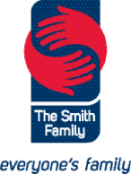

Variations in public data sets make it difficult to be precise about the numbers of children who are not enrolled in preschool, and those not attending to the rate of 600 hours. For a discussion of this, see the Preschool Participation Report in Appendix 2. (The Smith Family, 2019)
Because our research is based in NSW and Victoria, the majority of our practice examples come from these jurisdictions. This is not to imply that innovative responses to supporting family engagement with preschool are not occurring elsewhere in the country.
Name has been changed to protect the child’s identity.
Attended a preschool program Fairfield 75.5%, NSW 89.8%, Australia 92.4%; Vulnerable on two or more domains Fairfield 15.1%, NSW 9.6%, Australia 11% (AEDC, 2018b)
This assertion was not verified with data, however it is supported by child protection and juvenile justice data showing that these interventions are statistically more likely in locations of disadvantage, and that in the case of child protection data, the problems are continuing to rise. (AIHW, 2019a, 2019b)
For more information about free kinder for 3 and 4 year olds in Victoria: https://www.education.vic.gov.au/childhood/providers/funding/Pages/freekinder2021.aspx
For a more in-depth discussion of this issue, see https://theconversation.com/a-birth-certificate-is-a-human-right-why-arent-they-free-and-easier-to-get-146834
Research has found that children living in the most disadvantaged areas are least likely to have food provided in childcare. In metro areas of low income, the market demands that they provide food; if efficiencies have to made, so they do. Market competition means that food provision does not force the cost of care up; instead, it appears that services make cuts to staff.
Preschool attendance rate at Dubbo West Preschool: proportion (%) of enrolled children that attended preschool for at least 15 hours in the relevant reference week (Week 3 Term 4, 2020); 95% as required for the six monthly National Indigenous Australian Agency funding report.
A recent media article also highlights this issue: https://www.smh.com.au/national/nsw/it-doesn-t-make-sense-more-than-600-kindy-kids-suspended-last-year-20191115-p53b42.html
Names and identifying details have been changed to protect the privacy of individuals.
See Nanima Preschool Case Study
The Secretariat of National Aboriginal and Islander Child Care (SNAICC) states that ‘Cultural Protocols exist as standards of behaviour used by people to show respect to one another. Cultural protocol refers to the customs, lore and codes of behaviour of a particular cultural group and a way of conducting business. It also refers to the protocols and procedures used to guide the observance of traditional knowledge and practices, including how traditional knowledge is used, recorded and disseminated’ (SNAICC, 2021)
Recent research from Skattebol, J. et al. (2021) points out the unreliability of data relating to the participation of Aboriginal and Torres Strait Islander children in preschool. See http://doi.org/10.26190/5fa0c6861b8af
Due to COVID-19, we could not adhere to the face-to-face protocol of yarning. Instead, we adopted an extra-ordinary workshop to ensure inclusion under the circumstances.
For more information on The Early Years Learning Framework of Australia, see BELONGING, BEING & BECOMING (acecqa.gov.au) 8 Ways: www.8ways.online
Names and identifying details have been changed to protect the privacy of individuals.
Preschool Attendance rate at Nanima Preschool: Proportion (%) of enrolled children that attended preschool for at least 15 hours in the relevant reference week (Week 3 Term 1, 2020): 100 % (NIAA, 2020)

